CIVIL LAW PAPER II · ISLAMABAD HIGH COURT · CIVIL JUDGE-CUM-MAGISTRATE EXAMINATION 2026
Topic 1 · Muslim Family Law
Sources and schools · marriage · dower · divorce (talaq, khula, judicial dissolution) · iddat · maintenance · parentage · guardianship and custody · the Family Court
Knowledge Base — every concept in simple words, with rationale, cases, ratio decidendi and maxims

Prepared for: Ihtisham Ul Haq (Roll No. 999)
Paper: Civil Law-II — Tuesday, 27 October 2026, 2:00 PM to 5:00 PM (reporting 1:30 PM)
This volume: Topic 1 of 4 — Muslim family law, with the MFLO 1961, the Dissolution of Muslim Marriages Act 1939, the Guardians and Wards Act 1890 and the Family Courts Act 1964
Companion volumes: Topic 2 — Muslim law of property (inheritance, wills, gifts, waqf, pre-emption) · Topic 3 — Limitation Act 1908 · Topic 4 — Specific Relief Act 1877 and Registration Act 1908
Text of the law used: Official texts on pakistancode.gov.pk — MFLO 1961 (updated 2022, with the 2021 amendments), DMMA 1939 (2024), Shariat Application Act 1962 (2025), Guardians and Wards Act 1890, ICT Child Marriage Restraint Act 2025

Contents
How to use this knowledge base 4
What Civil Law Paper II covers 4
The statutes that apply in Islamabad 4
How the exam asks Muslim family law 5
Chapter 1 · Sources, schools and the application of Muslim law in Pakistan 7
1.1 Sources of Muslim law 7
1.2 Schools (madhahib) 7
1.3 Application in Pakistan 8
Chapter 2 · Marriage (nikah) 10
2.1 Meaning and nature 10
2.2 Essentials of a valid marriage 10
2.3 Guardians for marriage (wilayat al-ijbar) and the option of puberty 11
2.4 Prohibited relationships 11
2.5 Classification of marriages — valid, irregular, void 12
2.6 Statutory regulation 12
2.7 Effects of a valid marriage 13
2.8 Muta (temporary marriage) 14
Chapter 3 · Dower (mahr) 15
3.1 Meaning and nature 15
3.2 Kinds of dower 15
3.3 Rights of the wife and widow to secure her dower 16
3.4 Confirmation of dower 16
3.5 Dower on dissolution 17
3.6 Limitation for recovery of dower 17
3.7 Dower, dowry and bridal gifts distinguished 17
Chapter 4 · Talaq — divorce by the husband, and the MFLO procedure 19
4.1 Dissolution of marriage — the map 19
4.2 Talaq — meaning and capacity 19
4.3 Forms and modes of talaq 20
4.4 The procedure under MFLO s. 7 21
4.5 Talaq-e-tafweez (delegated divorce) 22
4.6 Consequences of divorce 22
Chapter 5 · Dissolution at the wife's instance — khula, mubarat and the DMMA 24
5.1 Khula 24
5.2 Mubarat 25
5.3 Judicial dissolution — DMMA s. 2 25
Chapter 6 · Iddat 29
6.1 Meaning 29
6.2 Philosophy — why iddat? 29
6.3 Periods of iddat 29
6.4 Is iddat compulsory in all separations? 30
6.5 Iddat and the MFLO 30
6.6 Legal effects of iddat 30
Chapter 7 · Maintenance (nafaqa) 31
7.1 Meaning and basis 31
7.2 Maintenance of the wife 31
7.3 Maintenance of children 31
7.4 Remedies for maintenance 31
Chapter 8 · Parentage, legitimacy and acknowledgment 33
8.1 Maternity and paternity 33
8.2 Presumptions of legitimacy 33
8.3 Acknowledgment of paternity (iqrar) 33
8.4 Adoption 34
Chapter 9 · Guardianship (wilayat) and custody (hizanat) 35
9.1 Three kinds of guardianship 35
9.2 Custody (hizanat) — the right of the mother 36
9.3 Disqualifications of a hazina 36
9.4 Guardianship of the property under Muslim law 36
9.5 The Guardians and Wards Act 1890 37
9.6 Visitation (meeting schedule) and modern practice 39
Chapter 10 · The Family Court — jurisdiction and procedure 41
10.1 Object 41
10.2 Exclusive jurisdiction — s. 5 and the Schedule 41
10.3 Procedure — step by step 42
10.4 The significance of pre-trial reconciliation — the LHC 2023 question 43
Chapter 11 · Maxims and the great distinctions 45
11.1 Maxims of Muslim family law 45
11.2 The great distinctions 45
Chapter 12 · Last-night revision sheet 47
zzTOCENDzz

How to use this knowledge base

What Civil Law Paper II covers
The IHC syllabus for Civil Law Paper II has four parts: (i) Muhammadan Law or Islamic Law; (ii) the Registration Act 1908; (iii) the Limitation Act 1908; and (iv) the Specific Relief Act 1877. These volumes divide the paper into four topics:
- Topic 1 — Muslim family law (this volume): marriage, dower, divorce, iddat, maintenance, parentage, guardianship and custody, with the statutes and the Family Court procedure under which these matters are decided.
- Topic 2 — Muslim law of property: inheritance, wills, gifts, waqf and pre-emption.
- Topic 3 — the Limitation Act 1908.
- Topic 4 — the Specific Relief Act 1877 and the Registration Act 1908.
COMMON MISTAKE · No bare Act for Muslim law
The syllabus note says that bare copies of the Acts may be consulted "except in case of Muhammadan Law or Islamic law". For Topics 1 and 2 you must remember the rules, the section numbers of the MFLO and DMMA, and the leading cases. This volume is therefore written to be memorised: each chapter ends with a short recap, and Chapter 12 is a last-night revision sheet.

The statutes that apply in Islamabad
Law | What it does
West Pakistan Muslim Personal Law (Shariat) Application Act 1962, s. 2 | Makes Muslim personal law (Shariat) the rule of decision, "notwithstanding any custom or usage", in questions of succession, special property of females, betrothal, marriage, divorce, dower, adoption, guardianship, minority, legitimacy, family relations, wills, legacies, gifts, waqfs and trusts — subject to any enactment (s. 2). Extends to the whole of Pakistan.
Muslim Family Laws Ordinance 1961 (MFLO) | Overrides any law, custom or usage (s. 3): succession of orphaned grandchildren (s. 4); registration of marriages (s. 5); polygamy (s. 6); talaq (s. 7); other dissolutions (s. 8); maintenance (s. 9); dower (s. 10). Amended in 2021 (Acts XXVIII and XXIX) for Fiqh-e-Jafria inheritance and talaq.
Dissolution of Muslim Marriages Act 1939 (DMMA) | Grounds on which a wife may obtain a decree dissolving her marriage (s. 2); effect of apostasy (s. 4); dower preserved (s. 5).
Family Courts Act 1964 (West Pakistan Act XXXV of 1964, applied in the Islamabad Capital Territory) | Exclusive jurisdiction of Family Courts over dissolution of marriage (including khula), dower, maintenance, restitution of conjugal rights, custody and guardianship, jactitation, dowry and personal property; special procedure; pre-trial reconciliation.
Guardians and Wards Act 1890 | Appointment, duties, powers and removal of guardians; custody of minors; the Family Court acts as the "District Court" for this Act.
ICT Child Marriage Restraint Act 2025 | Fixes 18 as the minimum age for both parties in the ICT; penalises child marriage; bars Nikah Registrars from registering it.
Dowry and Bridal Gifts (Restriction) Act 1976 | Limits dowry and bridal gifts; they vest absolutely in the bride.
Qanun-e-Shahadat 1984, Art. 128 | Conclusive proof of legitimacy (Chapter 8).
Constitution, Arts. 35, 227, 203D | Protection of marriage and family; laws to conform to Islam; the Federal Shariat Court's power to strike down laws repugnant to Islam.

ISLAMABAD-SPECIFIC LAW · The user's post — Civil Judge (Family / Presiding Officer)
The examination is for the post of Civil Judge-cum-Magistrate including Female Civil Judge (Family / Presiding Officer). In Islamabad, Civil Judges preside over Family Courts. Family-law questions are therefore not only about doctrine: examiners expect you to know how the Family Court decides these cases — pre-trial reconciliation, khula decrees, interim maintenance, custody and visitation orders. Chapter 10 deals with this.

How the exam asks Muslim family law
Paper | What it asked
KP High Court, Civil Law-II, 2026 | Modes and types of divorce and the process for it to become effective in Pakistan; "Dower is a debt" — the wife's remedies; the MFLO in the light of Allah Rakha v. Federation of Pakistan (PLD 2000 FSC 1); iddat — philosophy, kinds, whether compulsory in all separations
Lahore High Court, Civil Law-I, 2023 | A nikahnama condition that the husband will pay compensation on divorce — a clog on talaq or a valid agreement?; pre-trial reconciliation (s. 10, Family Courts Act); custody — qualifications and disqualifications of competing claimants; kinds of dower, when payable, and limitation for recovery
Lahore High Court, Civil Law-I, 2022 | Appointment of a guardian and the rights and obligations of the guardian; grounds for removal of guardians; the Family Court — jurisdiction, procedure, appeal; talaq procedure under the MFLO
Lahore High Court, Civil Law-I, 2020 | Guardianship and custody distinguished; welfare of the child; removal and cessation of authority of a guardian
LHC ASJ, Civil Law-I, 2020 and 2025 | Duties of a guardian of a minor's property and his removal; the Family Court's power in maintenance decrees; mediation in custody disputes
Sindh High Court, 2022 (short note) | Guardian of property of a ward and the limits of his powers

EXAM TIP · The pattern
Three areas dominate the papers: (1) divorce in all its forms and the MFLO s. 7 procedure; (2) dower; and (3) guardianship and custody under Muslim law and the Guardians and Wards Act. Master Chapters 3 (dower), 4–5 (divorce) and 9 (guardianship and custody) first.

Chapter 1 · Sources, schools and the application of Muslim law in Pakistan

1.1 Sources of Muslim law
Muslim law (Shariah — "the path"; its human understanding is fiqh) is derived from four primary sources and several secondary ones.
Source | Meaning and authority
Quran | The word of Allah — the first and supreme source. About 200 to 500 verses are legal (ayat al-ahkam), many on family law: marriage (4:3, 4:22–24), dower (4:4), divorce (2:228–232; 65:1–7), iddat (2:228, 2:234; 65:4), inheritance (4:11–12, 4:176).
Sunnah / Hadith | The practice and sayings of the Prophet (peace be upon him); explains and supplements the Quran (e.g., witnesses for nikah; the khula of the wife of Thabit bin Qays).
Ijma | Consensus of qualified jurists of the community on a legal question after the Prophet's time.
Qiyas | Analogical deduction — extending a rule to a new case having the same effective cause (illah). Accepted by Sunni schools; the Shia use aql (reason).
Secondary sources | Istihsan (juristic preference — Hanafi), istislah / maslaha mursala (public interest — Maliki), urf (custom, if not contrary to the texts), ijtihad (independent reasoning), legislation (MFLO, DMMA) and judicial precedent (Art. 189 of the Constitution).

1.2 Schools (madhahib)
- Sunni: Hanafi (Imam Abu Hanifa; the majority in Pakistan; his disciples Abu Yusuf and Imam Muhammad — the Sahibain), Maliki (Imam Malik), Shafi'i (Imam Shafi'i), Hanbali (Imam Ahmad bin Hanbal).
- Shia: Ithna Ashari / Jafari (the main Shia school in Pakistan), Ismaili, Zaidi.
Each Muslim is governed by the law of his or her own school. In Pakistan, Hanafi law is applied unless the parties are Shia. Since 2021, the MFLO expressly provides that the inheritance and divorce matters of Ahl-e-Tashih (Shia) are to be decided according to Fiqh-e-Jafria (MFLO ss. 4(8), 7(1A)), with recourse to a Mujtahid-e-Alam from a panel kept by the Council of Islamic Ideology, whose decision has the status of an arbitration award.
COMMON MISTAKE · Classical texts cited in Pakistani courts
- The Hedaya (Hanafi, by Burhanuddin al-Marghinani, 12th century; translated by Hamilton) and Fatawa-e-Alamgiri (Hanafi digest compiled under Aurangzeb).
- Sharaya-ul-Islam (Shia).
- Mulla, Principles of Mahomedan Law; Fyzee, Outlines of Muhammadan Law; Ameer Ali, Mohammedan Law; Tanzil-ur-Rahman, A Code of Muslim Personal Law.
Courts cite these by paragraph (e.g., "Mulla, para 287"). Quote them as authorities in the exam.

1.3 Application in Pakistan
- Shariat Application Act 1962, s. 2 — in the listed matters, "notwithstanding any custom or usage", the rule of decision is the Muslim personal law (Shariat) where the parties are Muslims, subject to any enactment. Section 3 terminated limited estates of Muslim females under customary law; ss. 4–5 dealt with successive legatees under wills.
- MFLO s. 3 — "The provisions of this Ordinance shall have effect notwithstanding any law, custom or usage." The MFLO therefore overrides classical rules where they conflict (e.g., the 90-day rule for talaq; the orphaned grandchild's share).
- Constitution, Art. 227 — all existing laws are to be brought into conformity with the Injunctions of Islam; Art. 203D — the Federal Shariat Court may examine whether a law is repugnant to Islam. Art. 203B(c) excludes "Muslim personal law" from the FSC's jurisdiction; the Supreme Court has read this as the personal law of each sect as interpreted by its own jurists, so statutes such as the MFLO can be examined by the FSC (Dr. Mahmood-ur-Rahman Faisal v. Government of Pakistan, PLD 1994 SC 607).
CASE STUDY · Allah Rakha v. Federation of Pakistan (PLD 2000 FSC 1)
Background. About thirty-seven petitions under Art. 203D challenged ss. 4 to 7 of the MFLO as repugnant to the Injunctions of Islam.
Held (Federal Shariat Court).
- Section 4 (orphaned grandchildren inherit their predeceased parent's share) — repugnant to the Injunctions of Islam, since under the Quranic scheme the nearer excludes the remoter (the remedy suggested was an obligatory bequest — wasiyyat wajibah — or other provision for them).
- Section 5 (registration of marriages) — not repugnant; registration is a useful administrative measure and does not affect validity.
- Section 6 (polygamy with the Arbitration Council's permission) — not repugnant; it regulates, and does not prohibit, a second marriage.
- Section 7(3) and (5) (talaq not effective until 90 days after notice to the Chairman; pregnancy) — repugnant, as talaq takes effect according to its own terms under Islamic law and the notice requirement cannot postpone it; the penal sanction for not giving notice was not itself struck down.
Status. Appeals were filed before the Shariat Appellate Bench of the Supreme Court (2000) and are reported to be pending. Under Art. 203D(2) and 203F, a decision under appeal does not take effect until the appeal is decided. The MFLO therefore continues to be applied as enacted, and courts in Islamabad apply ss. 4 and 7 in full.
Exam use. The KPHC 2026 paper asked candidates to "critically evaluate" the MFLO with reference to this case. Explain each section, the FSC's view, the pending appeal and its effect, and give your own reasoned evaluation (e.g., the welfare objects of ss. 6 and 7; the hardship to orphaned grandchildren that s. 4 cures).

QUICK RECAP · Chapter 1 in five lines
- Sources: Quran, Sunnah, Ijma, Qiyas; secondary — istihsan, istislah, urf, ijtihad, legislation, precedent.
- Schools: Hanafi (majority), Maliki, Shafi'i, Hanbali; Shia Jafari (MFLO ss. 4(8), 7(1A) since 2021).
- Shariat Application Act 1962, s. 2 — personal law governs Muslims notwithstanding custom, subject to enactments.
- MFLO overrides any law, custom or usage (s. 3); Art. 227; FSC may examine statutes (Mahmood-ur-Rahman Faisal).
- Allah Rakha (PLD 2000 FSC 1): ss. 4 and 7(3), (5) repugnant; ss. 5, 6 not; appeal pending — MFLO applied as enacted.

Chapter 2 · Marriage (nikah)

2.1 Meaning and nature
Marriage (nikah) is a contract for the legalisation of sexual intercourse and the procreation and legitimation of children (Hedaya). It is also a sacred institution and an act of ibadah (worship).
CASE STUDY · Abdul Kadir v. Salima ((1886) ILR 8 All 149, Mahmood J)
Held. "Marriage among Muhammadans is not a sacrament, but purely a civil contract." Its incidents — consent, consideration (dower), dissolution, enforcement of rights — are those of a contract. A husband could sue for restitution of conjugal rights although prompt dower was unpaid, once consummation had taken place.
Note. The modern view combines both aspects: a contract with religious and social dimensions (Anis Begum v. Muhammad Istafa Wali Khan, AIR 1933 All 634 — Sulaiman CJ). Pakistani courts stress its contractual basis (consent, mahr, terms in the nikahnama) and its sanctity.

2.2 Essentials of a valid marriage
- Proposal and acceptance (ijab and qabul) — by or on behalf of the parties, at one meeting (ittihad-e-majlis), in words that show a present intention to marry. A marriage contracted for a fixed period (muta) is void under Sunni law.
- Competence of the parties — each must be Muslim (subject to the kitabia rule), of sound mind, and have attained puberty (bulugh; presumed at 15 under classical Hanafi law). A minor or lunatic can be married by his or her guardian (wali) — subject now to the ICT Child Marriage Restraint Act 2025 (2.6).
- Free consent — consent obtained by force or fraud makes the marriage invalid unless ratified. An adult Muslim woman's own consent is essential and sufficient.
- Witnesses — under Hanafi law, two adult Muslim male witnesses, or one male and two females, must be present and hear the proposal and acceptance. Absence of witnesses makes the marriage irregular (fasid), not void. Under Shia law witnesses are not required.
- No legal prohibition — the parties must not be within the prohibited relationships (2.4).
- Dower — an incident, not a condition: if not fixed, the wife is entitled to proper dower (Chapter 3).
CASE STUDY · Hafiz Abdul Waheed v. Mrs. Asma Jahangir (PLD 2004 SC 219 — the "Saima Waheed case")
Facts. An adult woman, Saima Waheed, married without her father's consent. The father sought to have the marriage declared invalid for want of the wali's consent.
Held. Under the Hanafi school, an adult Muslim woman (sui juris) may contract her own marriage without the consent of her wali. The marriage was valid. (The Court noted the moral and social desirability of parental involvement, but this does not affect validity.)
Ratio. The consent of the parties, not of their guardians, is the essence of a Muslim marriage between adults.

2.3 Guardians for marriage (wilayat al-ijbar) and the option of puberty
Who may contract a minor's marriage (Hanafi order): (1) the father; (2) the father's father, how high soever; (3) the brother and other male relations on the father's side in the order of inheritance; (4) the mother; (5) maternal relations; (6) the State / Qazi.
Option of puberty (khiyar-ul-bulugh). A minor married by a guardian may repudiate the marriage on attaining puberty. In Pakistan this is codified in DMMA s. 2(vii):
"that she, having been given in marriage by her father or other guardian before she attained the age of sixteen years, repudiated the marriage before attaining the age of eighteen years: Provided that the marriage has not been consummated."
Points: (i) it applies to marriages by any guardian, including the father; (ii) the repudiation must be made before 18; (iii) the marriage must not have been consummated (consummation with her consent after puberty ends the option); (iv) she must obtain a decree from the Family Court.

2.4 Prohibited relationships
Kind | Who | Effect
Consanguinity (blood) | Ascendants, descendants, descendants of parents (brothers, sisters, nephews, nieces), immediate children of grandparents (uncles, aunts) — Quran 4:23 | Void (batil)
Affinity (marriage) | Wife's ascendants; wife's descendants (if the marriage with the wife was consummated); father's or son's wife | Void
Fosterage (rida'a) | Persons related through suckling within the first two years — the foster-mother and those related through her (with the recognised Hanafi exceptions) | Void
Unlawful conjunction | Two women so related that, if one were a man, they could not marry — e.g., two sisters, aunt and niece, at the same time | Irregular (Hanafi); void (Shia)
A fifth wife | While four marriages subsist (or one is in iddat) | Irregular
Absence of witnesses | Hanafi | Irregular
Difference of religion | A Muslim man may marry a kitabia (Christian or Jew), but not an idolater or fire-worshipper (irregular in Hanafi law); a Muslim woman may marry only a Muslim — Pakistani courts treat her marriage with a non-Muslim as void | Irregular / void
Woman undergoing iddat | — | Irregular (Hanafi); void (Shia)
Triply divorced wife | Cannot remarry the same husband without an intervening consummated marriage with another (halala) — but see MFLO s. 7(6) | Irregular / void
Polyandry | A married woman with another man | Void (and an offence)

MFLO s. 7(6): "Nothing shall debar a wife whose marriage has been terminated by talaq effective under this section from re-marrying the same husband, without an intervening marriage with a third person unless such termination is for the third time so effective." So the halala requirement applies only after a third effective talaq.

2.5 Classification of marriages — valid, irregular, void
Point | Valid (sahih) | Irregular (fasid) | Void (batil)
Defect | None | A temporary or curable impediment (no witnesses, fifth wife, unlawful conjunction, iddat, kitabi-idolater difference) | A permanent impediment (consanguinity, affinity, fosterage, another's wife)
Before consummation | Full effects | No effect; may be terminated by either party by words | No effect at all
After consummation | Full effects | Wife gets dower (proper or specified, whichever is less) and observes iddat; children legitimate; no mutual inheritance | No dower (in principle), no iddat; children illegitimate
Inheritance | Mutual | None between spouses | None

2.6 Statutory regulation

(1) Registration — MFLO s. 5
"Every marriage solemnized under Muslim Law shall be registered." The Union Council licenses Nikah Registrars; a marriage solemnised by someone else must be reported to the Nikah Registrar by the person who solemnised it, on pain of three months' simple imprisonment or Rs. 1,000 fine, or both (s. 5(3)–(4)). Non-registration does not invalidate the marriage; it remains valid and may be proved by other evidence (upheld in Allah Rakha). The nikahnama (Form II under the West Pakistan Muslim Family Laws Rules 1961) records dower, its mode of payment, delegation of the right of divorce (clause 18), restrictions on the husband's right of divorce, and other conditions (clauses 19–20).

(2) Polygamy — MFLO s. 6
- No man, during an existing marriage, shall contract another marriage except with the previous written permission of the Arbitration Council, and a marriage without permission shall not be registered (s. 6(1)).
- The application to the Chairman must state the reasons and whether the existing wife or wives consent (s. 6(2)).
- The Arbitration Council may grant permission if satisfied that the proposed marriage is "necessary and just" (s. 6(3)), recording reasons; revision lies to the Collector (s. 6(4)).
- Consequences of contravention (s. 6(5)): (a) the husband must pay immediately the entire dower, prompt or deferred, of the existing wife or wives — recoverable as arrears of land revenue; and (b) on complaint, simple imprisonment up to one year, or fine up to Rs. 5,000, or both.
- The second marriage remains valid in Muslim law (the MFLO does not declare it void), but the existing wife gets a ground for dissolution — DMMA s. 2(iia): "that the husband has taken an additional wife in contravention of the provisions of the Muslim Family Laws Ordinance, 1961".

(3) Child marriage — ICT Child Marriage Restraint Act 2025
- A child is a person under 18, male or female (s. 2(a)); a child marriage is one where either party is a child (s. 2(e)).
- No Nikah Registrar shall register a marriage where a party is under 18, and must verify CNICs with dates of birth (s. 3) — penalty up to one year and Rs. 100,000 fine.
- An adult male who contracts a child marriage — rigorous imprisonment of two to three years and fine (s. 4); cohabitation resulting from a child marriage is child abuse — five to seven years and a fine of not less than Rs. 1 million (s. 5); child trafficking for marriage (s. 6); a parent or guardian who promotes, permits or negligently fails to prevent a child marriage — two to three years (s. 7), with a presumption against the person in charge of the child.
- Only the Court of Sessions tries these offences (s. 8); it may issue an injunction prohibiting an intended child marriage (s. 9); offences are cognizable, non-bailable and non-compoundable (s. 10); trial within 90 days (s. 11). The Child Marriage Restraint Act 1929 is repealed for the ICT (s. 13).
- Validity. Like the 1929 Act, the 2025 Act punishes child marriage but does not expressly declare it void; the validity of such a marriage is governed by Muslim law (with the minor's option of puberty — DMMA s. 2(vii)).

2.7 Effects of a valid marriage
- Cohabitation becomes lawful; children are legitimate.
- The wife is entitled to dower (Chapter 3) and maintenance (Chapter 7).
- Mutual rights of inheritance arise (Topic 2).
- Prohibited degrees of affinity arise.
- The wife must observe iddat on dissolution (Chapter 6).
- The wife retains her separate legal personality and property; the husband acquires no rights over her property.
- Restitution of conjugal rights — either spouse who withdraws from the society of the other without lawful cause may be sued in the Family Court; non-payment of prompt dower is a good defence for the wife before consummation (and, in Pakistani practice, a ground the courts weigh afterwards too); cruelty, non-maintenance, or an unregistered second marriage may also defeat the husband's suit.

2.8 Muta (temporary marriage)
A marriage for a fixed period for a fixed dower, recognised only in Ithna Ashari (Shia) law. No mutual inheritance (unless agreed); the wife is not entitled to maintenance (unless agreed); no divorce — it ends on expiry of the term; children are legitimate. It is void in Sunni law.
QUICK RECAP · Chapter 2 in eight lines
- Nikah: a civil contract (Abdul Kadir v. Salima) with sacred character; proposal and acceptance at one meeting.
- Essentials: competent parties (Muslim, sane, pubescent), free consent, two witnesses (Hanafi), no prohibition; dower an incident.
- Adult woman may marry without wali (Hafiz Abdul Waheed v. Asma Jahangir, PLD 2004 SC 219).
- Guardians for marriage: father, grandfather, agnates, mother…; option of puberty — DMMA s. 2(vii): married before 16, repudiate before 18, no consummation.
- Prohibitions: consanguinity, affinity, fosterage (void); conjunction, fifth wife, no witnesses, iddat, religion (irregular); halala only after the third talaq (MFLO s. 7(6)).
- Valid / irregular / void — effects on dower, iddat, legitimacy and inheritance.
- MFLO s. 5 registration (not affecting validity); s. 6 polygamy — permission, whole dower payable, punishment, DMMA s. 2(iia).
- ICT Child Marriage Restraint Act 2025: 18 for both; punishments; Sessions Court; injunction; 90-day trial.

Chapter 3 · Dower (mahr)

3.1 Meaning and nature
Dower (mahr) is a sum of money or other property which the wife is entitled to receive from the husband in consideration of the marriage (Mulla). It is ordained by the Quran: "And give the women (on marriage) their dower as a free gift" (4:4).
Purpose: (i) a mark of respect for the wife; (ii) a check on the husband's arbitrary power of divorce; (iii) financial security for the wife after dissolution.
LEGAL MAXIM · "Dower is a debt"
Dower is not the price of the wife; it is an obligation imposed by law on the husband as a token of respect, and once fixed (or once proper dower is due) it is a debt owed to the wife, ranking with other unsecured debts of the husband and recoverable from his estate after death (Hamira Bibi v. Zubaida Bibi (1916) 43 IA 294, PC). This is the theme of the KPHC 2026 question.

3.2 Kinds of dower
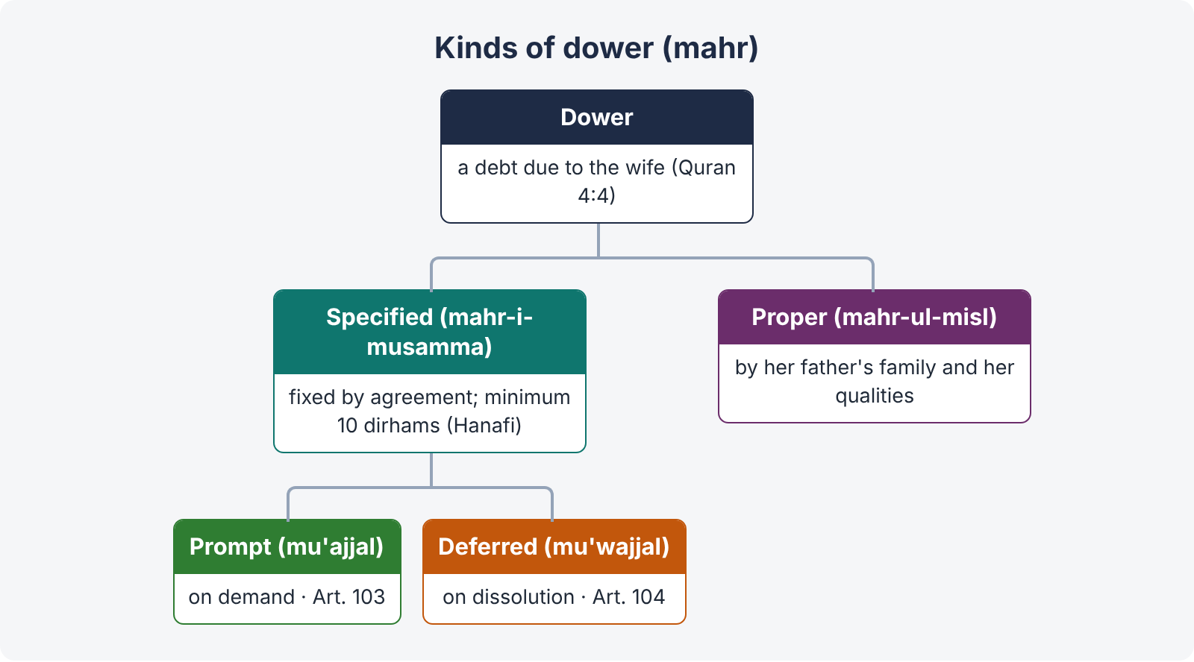
Figure 1 · Kinds of dower

(1) Specified dower (mahr-i-musamma)
Fixed by agreement, before, at, or after the marriage. Under Hanafi law the minimum is ten dirhams; there is no maximum (the husband may fix any amount, even beyond his means — but courts look at good faith). The husband may increase it after the marriage. A guardian may fix the dower of a minor, binding on the minor.
Specified dower is either:
- Prompt (mu'ajjal) — payable immediately on demand after the marriage; or
- Deferred (mu'wajjal) — payable on dissolution of the marriage by death or divorce, or on a specified event. The wife cannot demand deferred dower during the marriage (unless the event occurs), but interest in it vests at marriage.
MFLO s. 10: "Where no details about the mode of payment of dower are specified in the nikah nama, or the marriage contract, the entire amount of the dower shall be presumed to be payable on demand." (Classical Hanafi law divided it according to custom; s. 10 replaces that rule in Pakistan.)

(2) Proper or customary dower (mahr-ul-misl)
Where no dower is fixed (or the fixation is invalid), the wife is entitled to proper dower, determined by reference to the dower of women of her father's family (sisters, paternal aunts), and her age, beauty, fortune, understanding and virtue, and the social position of her family. The right exists even if the marriage contract excluded dower.

3.3 Rights of the wife and widow to secure her dower
- Refusal of cohabitation. Before consummation, a wife may refuse to live with her husband until prompt dower is paid; the husband's suit for restitution of conjugal rights then fails (Nasra Begum v. Rizwan Ali, AIR 1980 All 119). After consummation, the classical position was that she could not refuse (Abdul Kadir v. Salima); courts in Pakistan still consider non-payment a relevant factor in refusing restitution.
- Suit for recovery — a suit in the Family Court (Family Courts Act, Schedule). A wife may sue for prompt dower at any time during the marriage, and for deferred dower on dissolution.
- Dower as a debt against the husband's estate — after his death, the widow (and her heirs if she dies) may claim the dower as a debt from his estate, before distribution among heirs (Topic 2 — debts are paid before inheritance). Her claim is unsecured, ranking with other creditors (Hamira Bibi).
- Widow's right of retention. A widow who has lawfully obtained possession of her husband's property (with his or his heirs' consent, not by force or fraud) in lieu of unpaid dower is entitled to retain it until her dower is paid. The right: (i) does not give her title to the property; (ii) she cannot alienate it (Maina Bibi v. Chaudhri Vakil Ahmad (1925) 52 IA 145, PC — her transfer of the property did not bind the heirs); (iii) she must account for the income; (iv) it is heritable in the sense that it passes to her heirs with the debt; (v) it gives no priority over other creditors.
- Polygamy without permission — the entire dower, prompt and deferred, becomes payable at once and is recoverable as arrears of land revenue (MFLO s. 6(5)(a)).
- DMMA s. 5 — a decree of dissolution under the Act does not affect the wife's right to dower.

3.4 Confirmation of dower
The whole specified dower becomes due (is confirmed) on: (i) consummation; (ii) a valid retirement (khilwat-us-sahiha — the spouses alone together in circumstances where there is no legal, moral or physical impediment to intercourse); (iii) the death of either spouse (even before consummation).
Divorce before consummation or valid retirement: the wife gets half the specified dower (Quran 2:237); if no dower was specified, she gets a present (mut'a — e.g., three articles of dress).

3.5 Dower on dissolution
Mode of dissolution | Dower
Talaq after consummation | Entire dower (prompt and deferred) becomes due.
Talaq before consummation | Half the specified dower (or a present if none specified).
Death | Entire dower due (confirmed by death).
Khula | The wife usually returns dower or other benefits as consideration; in a Family Court decree under s. 10(4) Family Courts Act, the court directs restoration of the haq mehr received "in consideration of marriage at the time of marriage" (Chapter 5).
Mubarat | As agreed; usually mutual release.
Judicial dissolution under the DMMA | Dower not affected (s. 5) — the wife keeps her right to dower, unless the court, in a khula-type decree, orders otherwise.
Apostasy | DMMA s. 4: a woman's apostasy does not by itself dissolve the marriage.

3.6 Limitation for recovery of dower
Dower | Period | Time runs from (Limitation Act, First Schedule)
Prompt (exigible) — Art. 103 | Three years | "When the dower is demanded and refused or (where, during the continuance of the marriage no such demand has been made) when the marriage is dissolved by death or divorce."
Deferred — Art. 104 | Three years | "When the marriage is dissolved by death or divorce."

So a wife who never demanded her prompt dower during the marriage does not lose it; time starts only on dissolution. Once she demands and the husband refuses, time runs from the refusal.

3.7 Dower, dowry and bridal gifts distinguished
- Dower (mahr) — from the husband to the wife; an obligation of Muslim law.
- Dowry (jahez) — property given by the bride's parents to the bride in connection with marriage.
- Bridal gifts (bari) — gifts from the bridegroom or his family to the bride.
Under the Dowry and Bridal Gifts (Restriction) Act 1976, the dowry, bridal gifts and presents given to the bride vest absolutely in her, and her property in them may not be restricted; the Act also limits their value and requires lists to be prepared and delivered to the Registrar. A wife may recover dowry articles in the Family Court (Schedule: "dowry" and "personal property and belongings of a wife").
ILLUSTRATION · The nikahnama condition — LHC 2023
A nikahnama provides that, if the husband divorces the wife, he will pay her Rs. 2 million as compensation. Is this a clog on his right of talaq (and so void), or a valid agreement?
- Muslim law permits conditions in the marriage contract that are not contrary to the purpose of marriage or the Shariah; a condition that destroys the husband's right of talaq would be invalid, but one that merely makes divorce costly is generally upheld as a form of additional dower or financial security for the wife.
- The prevailing approach of Pakistani courts is to treat such a stipulation as part of the wife's dower or a contractual entitlement in her favour, recoverable in the Family Court, unless it is oppressive or penal (Contract Act s. 74 by analogy) or contrary to public policy. The Family Court has jurisdiction because the claim arises out of the marriage contract and the nikahnama.
- A better-drafted answer distinguishes: (i) a fixed sum stated as deferred dower payable on divorce — enforceable as dower; (ii) a penalty designed only to prevent divorce — may be reduced or refused as a clog; (iii) conditions in clauses 17–19 of the nikahnama (delegated right of divorce, restrictions on polygamy) — valid.

QUICK RECAP · Chapter 3 in eight lines
- Dower: money or property due to the wife in consideration of marriage (Quran 4:4); respect, check on divorce, security.
- "Dower is a debt" — unsecured debt against the husband and his estate (Hamira Bibi).
- Specified (minimum 10 dirhams Hanafi; prompt or deferred) and proper dower (by her father's family and personal qualities).
- MFLO s. 10 — where mode of payment not specified, the whole dower is payable on demand.
- Rights: refuse cohabitation before consummation (Nasra Begum); suit; claim against estate; widow's right of retention — no title, no alienation (Maina Bibi).
- Confirmed by consummation, valid retirement or death; half on divorce before consummation.
- Polygamy without permission — entire dower at once, as land revenue (MFLO s. 6(5)).
- Limitation: prompt — 3 years from demand and refusal, or dissolution (Art. 103); deferred — 3 years from dissolution (Art. 104). Dowry and bridal gifts vest in the bride (Act of 1976).

Chapter 4 · Talaq — divorce by the husband, and the MFLO procedure

4.1 Dissolution of marriage — the map
A Muslim marriage may be dissolved in the following ways:
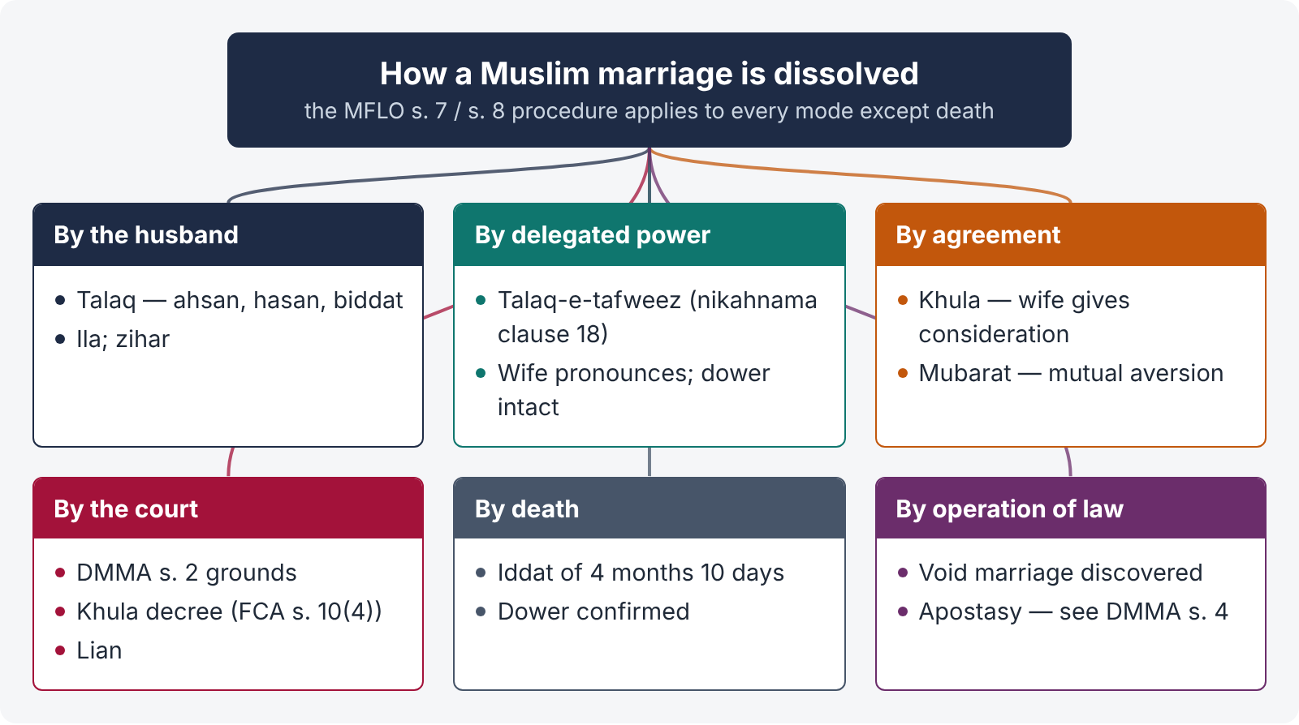
Figure 2 · Modes of dissolution of a Muslim marriage
- By death of either spouse.
- By the husband — talaq; and the rare forms ila (vow of continence for four months or more) and zihar (comparing the wife to a prohibited female relation).
- By the wife, under a delegated power — talaq-e-tafweez.
- By mutual agreement — khula (at the wife's instance, for consideration) and mubarat (mutual release).
- By judicial decree — under the DMMA 1939 (including khula decreed by the Family Court, and lian).
- By operation of law — e.g., discovery of a void marriage; in classical law, apostasy of the husband (but see DMMA s. 4 for the wife).
LEGAL MAXIM · "Of all lawful things, the most hateful to Allah is divorce" (Hadith, Abu Dawud)
Islam permits divorce as a necessary remedy for a failed marriage, but discourages its abuse. The Quran prescribes arbitration before divorce (4:35) and iddat as a period of reflection (65:1). The MFLO's notice and Arbitration Council reflect the same policy.

4.2 Talaq — meaning and capacity
Talaq means "release" — the repudiation of the marriage by the husband, by words or in writing, without any need to give reasons or to go to court.
Capacity (Hanafi): a husband who is adult (has attained puberty) and of sound mind. Classical Hanafi law holds valid even a talaq pronounced under compulsion, in jest, or in voluntary intoxication; Shia law requires a free intention and the presence of witnesses. For Fiqh-e-Jafria, the MFLO (2021 proviso to s. 7(1)) now provides that the man may pronounce talaq himself or through a duly authorised vakil, "uttering in literal Arabic words (seegha) in the physical presence of at least two witnesses qualifying the requirements of clause (1) of Article 17 of the Qanun-e-Shahadat"; and that the pronouncement "shall be ineffective if it is done jokingly or under anger, intoxication, insanity, duress or coercion of any kind".
Pakistani courts have increasingly refused to give effect to a talaq proved to have been obtained by coercion, or pronounced in a state in which the husband did not understand what he was saying, treating the intention of the husband as decisive.

4.3 Forms and modes of talaq
Forms: (i) express (sarih) — clear words ("I divorce you"), effective without proof of intention; (ii) implied / ambiguous (kinaya) — words capable of other meanings ("you are free"), effective only if intention is proved; (iii) oral or written (talaqnama) — a written talaq takes effect as the deed states (subject to the MFLO).
Modes:
Mode | Method | Revocability
Talaq-e-ahsan (most approved) | A single pronouncement during a period of purity (tuhr) in which there has been no intercourse, followed by abstinence during the iddat | Revocable during iddat (by words or resumption of cohabitation); becomes final on expiry of iddat
Talaq-e-hasan (approved) | Three pronouncements in three successive tuhrs, without intercourse in between | Revocable after the first and second; irrevocable on the third — remarriage only after halala
Talaq-ul-biddat (innovative / "triple talaq") | Three pronouncements at one time ("I divorce you, I divorce you, I divorce you"), or one pronouncement clearly intended to be irrevocable | Irrevocable at once in classical Hanafi law (Rashid Ahmad v. Anisa Khatun (1932) 59 IA 21, PC); not recognised as three by Shia law

CASE STUDY · Rashid Ahmad v. Anisa Khatun ((1932) 59 IA 21, Privy Council)
Facts. A husband pronounced three talaqs in the absence of his wife and executed a talaqnama, but afterwards continued to live with her and treated her as his wife; children were born.
Held. Under Hanafi law, a triple talaq is effective and irrevocable from the moment of pronouncement, even though it is sinful (biddat). The later cohabitation could not revive the marriage without an intervening marriage of the wife with another man; the children were held illegitimate.
Pakistan today. The MFLO has changed the practical result: under s. 7(3) no talaq is effective until 90 days after notice to the Chairman, and it may be revoked in that period; under s. 7(6) the wife may remarry the same husband without halala "unless such termination is for the third time so effective". A "triple" pronouncement made at one time produces one termination under s. 7, so it does not by itself bar remarriage without halala.

Ila and zihar
- Ila — the husband swears not to have intercourse with his wife for four months or more and keeps the vow: under Hanafi law the marriage is dissolved on the expiry of four months (Quran 2:226–227).
- Zihar — the husband compares his wife to a woman within his prohibited degrees (e.g., "you are to me as my mother's back"): he may not resume cohabitation until he performs expiation (kaffara); the wife may seek dissolution (DMMA s. 2(ix)).

4.4 The procedure under MFLO s. 7
"7. (1) Any man who wishes to divorce his wife shall, as soon as may be after the pronouncement of talaq in any form whatsoever, give the Chairman notice in writing of his having done so, and shall supply a copy thereof to the wife."
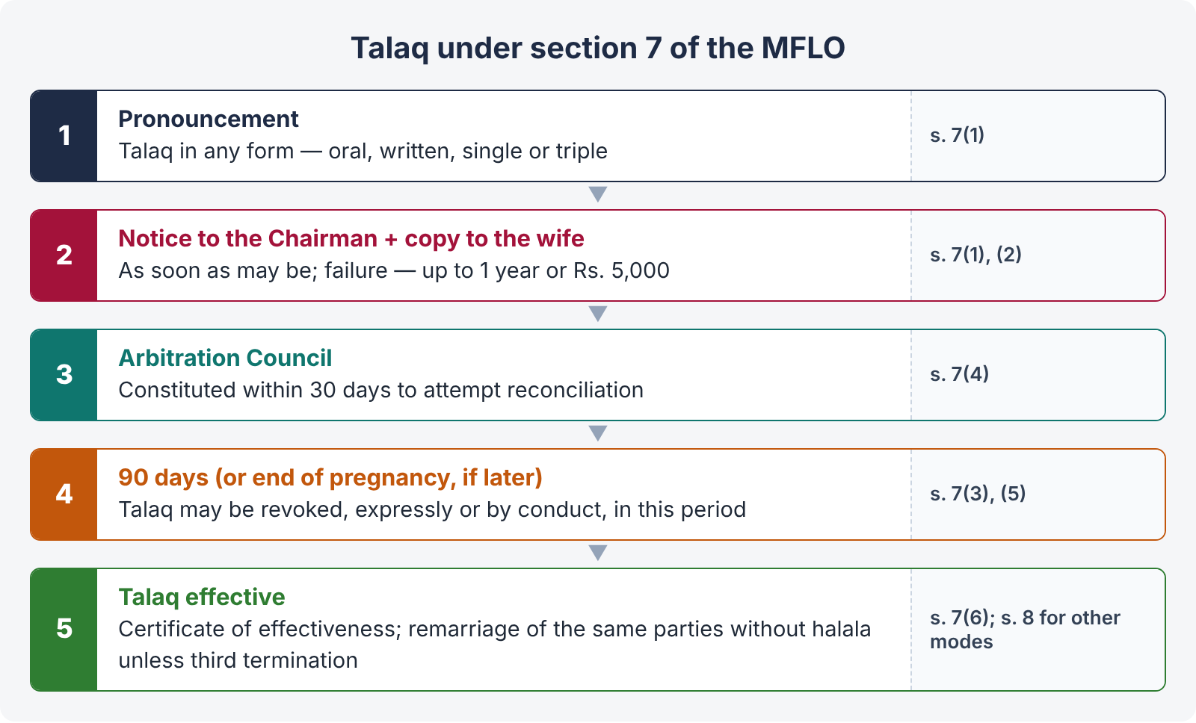
Figure 3 · The talaq procedure under section 7 of the MFLO
- Pronouncement of talaq in any form (oral, written, single, triple).
- Written notice to the Chairman of the Union Council (in the ICT, the Chairman under the ICT Local Government Act 2015, or a person appointed by the Government), with a copy to the wife.
- Penalty for not giving notice — simple imprisonment up to one year, or fine up to Rs. 5,000, or both (s. 7(2)).
- Arbitration Council — within 30 days of receiving the notice, the Chairman shall constitute an Arbitration Council (the Chairman and a representative of each party — s. 2(a)) "for the purpose of bringing about a reconciliation", and it "shall take all steps necessary" for that purpose (s. 7(4)).
- Effectiveness — "Save as provided in sub-section (5), a talaq unless revoked earlier, expressly or otherwise shall not be effective until the expiration of ninety days from the day on which notice under sub-section (1) is delivered to the Chairman" (s. 7(3)).
- Pregnancy — "If the wife be pregnant at the time talaq is pronounced, talaq shall not be effective until the period mentioned in sub-section (3) or the pregnancy, whichever be later, ends" (s. 7(5)).
- Revocation — the husband may revoke the talaq within the 90 days, expressly or otherwise (e.g., by resuming cohabitation).
- Remarriage of the same parties — permitted without halala, unless this is the third effective termination (s. 7(6)).
- Certificate — after 90 days, the Union Council issues a certificate of effectiveness of divorce, which is the usual proof of divorce for NADRA and remarriage.
- Section 8 applies the same procedure, mutatis mutandis, to talaq-e-tafweez and to dissolution "otherwise than by talaq" (khula, mubarat).

Effect of failure to give notice
- The husband is liable to punishment (s. 7(2)).
- On validity, the superior courts have not spoken with one voice. The predominant view is that, the MFLO having overriding effect (s. 3), a talaq of which no notice is given to the Chairman does not become effective under s. 7(3), and the marriage subsists until notice is given and 90 days pass. Another line of decisions — reflected in the FSC's view in Allah Rakha that s. 7(3) is repugnant to Islam — treats a talaq proved to have been pronounced as effective despite the absence of notice. As the FSC judgment is under appeal and not in effect, the safer statement of the law in the exam is: the date on which talaq becomes effective is reckoned from the notice to the Chairman, and the courts look at the whole conduct of the parties (e.g., an admitted talaq followed by long separation).
- The Arbitration Council's failure to meet or to attempt reconciliation does not prevent the talaq from becoming effective after 90 days.

4.5 Talaq-e-tafweez (delegated divorce)
The husband may delegate his power of talaq to the wife (or to a third person), absolutely or on conditions — e.g., if he marries again without her consent, or fails to maintain her. In Pakistan this is done through clause 18 of the nikahnama ("whether the husband has delegated the power of divorce to the wife, and if so, under what conditions").
- The delegation, once made, is irrevocable by the husband.
- The wife exercises it by pronouncing talaq on herself; the marriage is dissolved as if the husband had pronounced it — without any court decree.
- The MFLO s. 8 procedure applies: she must give notice to the Chairman, and the dissolution takes effect after 90 days (s. 7(3) applied mutatis mutandis).
- The wife does not lose her dower, since the dissolution is in law by the husband's act (through his agent).

4.6 Consequences of divorce
- Cohabitation becomes unlawful after the talaq becomes effective (in practice, after the 90 days).
- The wife must observe iddat (Chapter 6), unless the marriage was not consummated.
- Dower — the whole (if consummated) becomes immediately payable; half if not consummated.
- Maintenance — during iddat (Hanafi), not afterwards; children's maintenance continues.
- Mutual rights of inheritance cease once the talaq is effective (a wife divorced by a husband on his death-bed — marz-ul-maut — to deprive her of inheritance may still inherit if he dies during her iddat: Hanafi rule).
- Remarriage — the wife may remarry another after the talaq is effective and iddat is over; the same husband — subject to s. 7(6).
- Custody of children — governed by the rules of hizanat (Chapter 9).
QUICK RECAP · Chapter 4 in eight lines
- Dissolution by death, by husband (talaq, ila, zihar), delegated (tafweez), agreement (khula, mubarat), court (DMMA), operation of law.
- Talaq: adult, sane husband; express / implied; oral / written; Fiqh-e-Jafria — Arabic words, two witnesses, ineffective in jest, anger, intoxication, duress (MFLO s. 7(1) proviso, 2021).
- Modes: ahsan (single, revocable in iddat), hasan (three tuhrs), biddat (triple — irrevocable in Hanafi law: Rashid Ahmad v. Anisa Khatun).
- MFLO s. 7: notice to Chairman + copy to wife; Arbitration Council within 30 days; effective after 90 days unless revoked; pregnancy — later of the two; penalty up to one year / Rs. 5,000.
- s. 7(6): remarriage without halala unless third effective termination — a triple pronouncement counts as one termination.
- Non-notice: penal; effectiveness reckoned from notice (predominant view); Allah Rakha contrary but under appeal.
- Tafweez: clause 18 nikahnama; wife pronounces; s. 8 procedure; dower intact.
- Consequences: iddat, dower due, iddat maintenance, inheritance ends (except marz-ul-maut), remarriage, custody.

Chapter 5 · Dissolution at the wife's instance — khula, mubarat and the DMMA

5.1 Khula
Khula (from khal' — to put off, as a garment: "they are your garments and you are their garments", Quran 2:187) is a dissolution of marriage at the instance of the wife, in return for a consideration (usually the return of dower or other benefits) paid to the husband.
Quranic basis: "If you fear that they would not be able to keep the limits ordained by Allah, there is no blame on either of them if she gives something for her freedom" (2:229). Sunnah: the wife of Thabit bin Qays came to the Prophet and said she found no fault in his character or religion but could not live with him; the Prophet asked, "Will you return his garden (the dower)?" She agreed, and the Prophet directed Thabit to accept the garden and divorce her.

Is the husband's consent necessary?
Classical Hanafi texts treat khula as a contract requiring the husband's acceptance. Pakistani courts have held that the court may decree khula without the husband's consent, where it is satisfied that the spouses cannot live together within the limits prescribed by Allah.
CASE STUDY · Mst. Balqis Fatima v. Najm-ul-Ikram Qureshi (PLD 1959 Lahore 566, Full Bench)
Held. A wife is entitled to dissolution by khula through the court if the court is satisfied that, in the circumstances, the parties cannot live together in harmony and within the limits of Allah; the husband's consent is not necessary, and the wife must restore what she received (consideration). The ground is covered by DMMA s. 2(ix) ("any other ground which is recognised as valid for the dissolution of marriages under Muslim law").

CASE STUDY · Mst. Khurshid Bibi v. Baboo Muhammad Amin (PLD 1967 SC 97)
Held. The Supreme Court affirmed that a Muslim wife is entitled to khula as of right if she satisfies the court that she would otherwise be forced into a hateful union; she need not prove any fault of the husband. The court's role is to be satisfied that the "limits of Allah" cannot be kept, and to fix the consideration (ordinarily the return of the dower received). An aversion so strong that cohabitation is impossible is enough.
Ratio. Khula is the wife's right, enforceable by the court, corresponding to the husband's right of talaq.

Khula in the Family Court — s. 10(4), Family Courts Act
By the 2002 amendment (applicable in the ICT), in a suit for dissolution of marriage, if reconciliation fails at the pre-trial stage, "the Family Court shall pass decree for dissolution of marriage forthwith and shall also restore to the husband the haq mehr received by the wife in consideration of marriage at the time of marriage". So a wife who seeks khula need not go through a full trial: if the pre-trial reconciliation fails, the decree follows, conditional on restoring the dower received (not unpaid deferred dower, which she simply forgoes).

Effect of khula
- It operates as a single irrevocable (bain) talaq (Hanafi).
- The wife must observe iddat.
- She loses the dower she agreed (or was ordered) to return, and any deferred dower claim she gave up.
- Children's maintenance and custody are not affected by the consideration; a khula agreement cannot validly waive the children's right of maintenance.
- A certified copy of the decree is sent to the Chairman within seven days, and the decree becomes effective after 90 days from the day the copy is sent (s. 21, Family Courts Act).

5.2 Mubarat
Mubarat is dissolution by mutual consent where both desire separation (mutual aversion). The offer may come from either side; on acceptance it operates as an irrevocable divorce. Usually each releases the other's claims. The MFLO s. 8 procedure applies.
Point | Khula | Mubarat
Initiative | Wife | Either party
Aversion | On the wife's side | Mutual
Consideration | Wife gives consideration to the husband | Usually mutual release; no consideration necessary
Court | May be decreed by court without the husband's consent (Khurshid Bibi) | By agreement only

5.3 Judicial dissolution — DMMA s. 2
"A woman married under Muslim Law shall be entitled to obtain a decree for the dissolution of her marriage on any one or more of the following grounds, namely:—"
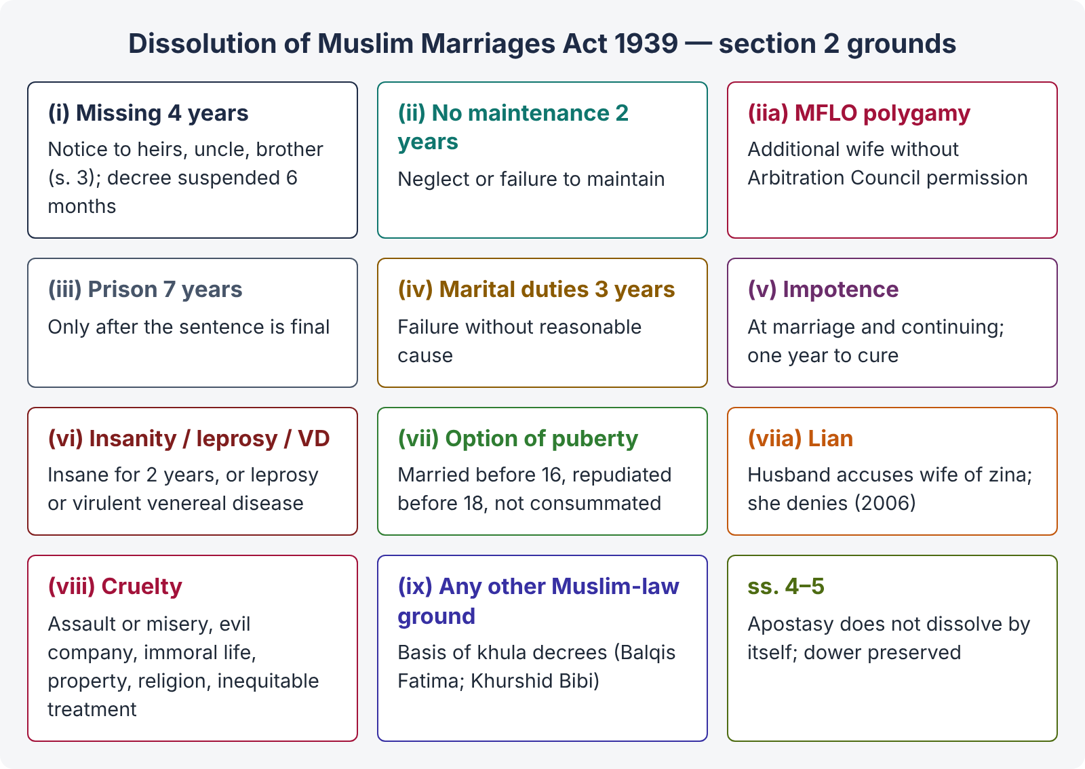
Figure 4 · Grounds for dissolution under the DMMA, section 2
Clause | Ground | Notes
(i) | Whereabouts of the husband not known for four years | Plaint must name the husband's heirs; notice to them, and to the husband's paternal uncle and brother even if not heirs (s. 3). The decree does not take effect for six months; if the husband appears within that time and satisfies the court that he is prepared to perform his conjugal duties, the court shall set aside the decree (proviso (b)).
(ii) | Husband has neglected or failed to provide maintenance for two years | Whether the wife's own refusal to live with him without just cause defeats this ground has been differently decided; the modern tendency is to grant the decree on proof of the failure, the husband's remedy being restitution of conjugal rights.
(iia) | Husband has taken an additional wife in contravention of the MFLO | Inserted by MFLO s. 13 (1961). Contravention of s. 6 = no prior permission.
(iii) | Husband sentenced to imprisonment for seven years or upwards | No decree until the sentence is final (proviso (a)).
(iv) | Husband has failed to perform marital obligations, without reasonable cause, for three years | Marital obligations include cohabitation and conjugal relations.
(v) | Husband was impotent at the time of marriage and continues to be so | On the husband's application, the court shall give him one year to show he has ceased to be impotent; if he does, no decree (proviso (c)).
(vi) | Husband has been insane for two years, or suffers from leprosy or a virulent venereal disease | —
(vii) | Option of puberty — given in marriage by father or other guardian before 16, repudiated before 18, marriage not consummated | Chapter 2.
(viia) | Lian — the husband has accused his wife of zina and the wife does not accept the accusation as true | Inserted by the Protection of Women (Criminal Laws Amendment) Act 2006.
(viii) | Cruelty — (a) habitual assault or making her life miserable by cruelty of conduct, even without physical ill-treatment; (b) associating with women of evil repute or leading an infamous life; (c) attempting to force her to lead an immoral life; (d) disposing of her property or preventing her from exercising her legal rights over it; (e) obstructing her in the observance of her religious profession or practice; (f) if he has more wives than one, not treating her equitably in accordance with the injunctions of the Quran | Mental cruelty suffices; each sub-clause is a separate ground.
(ix) | Any other ground recognised as valid for dissolution under Muslim law | The basis of khula decrees (Balqis Fatima), and of grounds such as ila and zihar.

Other provisions:
- s. 4 — apostasy: "The renunciation of Islam by a married Muslim woman or her conversion to a faith other than Islam shall not by itself operate to dissolve her marriage", but she may obtain a decree on any s. 2 ground; this does not apply to a woman converted to Islam from another faith who re-embraces her former faith.
- s. 5 — dower: nothing in the Act affects her right to dower on dissolution.
Procedure. A suit for dissolution lies to the Family Court (Family Courts Act, Schedule, item 1). After the decree, the s. 21 procedure (copy to Chairman; effective after 90 days) applies.
ILLUSTRATION · Choosing the right ground
Sadia's husband, a trader in G-9, married a second wife without the Arbitration Council's permission, has not paid her maintenance for 14 months, and frequently abuses her. She wants a divorce and to keep her dower. Her best grounds are s. 2(iia) (second marriage without permission — also making her entire dower immediately payable, MFLO s. 6(5)) and s. 2(viii)(a) (cruelty of conduct) and, if she prefers, s. 2(viii)(f) (inequitable treatment). Ground (ii) is not yet available (two years). On these grounds she keeps her dower (s. 5). If she sued only for khula, the decree would follow on failure of pre-trial reconciliation, but she would have to restore the dower received (s. 10(4), Family Courts Act).

QUICK RECAP · Chapter 5 in six lines
- Khula: wife's release for consideration (Quran 2:229; Thabit bin Qays); court may decree without husband's consent (Balqis Fatima, PLD 1959 Lah 566 FB; Khurshid Bibi, PLD 1967 SC 97).
- Family Courts Act s. 10(4): if pre-trial reconciliation fails — decree forthwith; restore haq mehr received; effective 90 days after copy to Chairman (s. 21).
- Khula = single irrevocable talaq; iddat; dower returned / forgone; children's rights unaffected. Mubarat: mutual aversion, mutual release.
- DMMA s. 2: (i) 4 years missing (6-month suspension; heirs, uncle, brother — s. 3); (ii) 2 years' non-maintenance; (iia) MFLO polygamy; (iii) 7 years' prison (final); (iv) 3 years' marital failure; (v) impotence (1-year chance).
- (vi) insanity 2 years / leprosy / VD; (vii) option of puberty (16 / 18); (viia) lian; (viii) cruelty (a)–(f); (ix) any other Muslim-law ground (khula).
- s. 4 apostasy does not dissolve by itself; s. 5 dower preserved.

Chapter 6 · Iddat

6.1 Meaning
Iddat ("counting") is the period of waiting which a woman must observe after the dissolution of her marriage, by divorce or death, before she can lawfully remarry.

6.2 Philosophy — why iddat?
- Certainty of paternity — to ascertain whether she is pregnant by the former husband, so that the parentage of a child is not confused (ikhtilat-un-nasab).
- Reconciliation — in a revocable divorce, the iddat gives the husband time to revoke and the couple time to reflect (Quran 65:1: "you know not; it may be that Allah will thereafter bring about some new situation").
- Mourning and respect — in the case of death, a period of mourning (hidad) and respect for the marriage tie.
- Protection of the woman — she is entitled to residence and maintenance during the iddat of divorce (Quran 65:6).

6.3 Periods of iddat
Situation | Period
Divorce (talaq, khula, mubarat, judicial dissolution) — woman who menstruates | Three menstrual courses (qur'u) (Quran 2:228)
Divorce — woman who does not menstruate (minor, or past menopause) | Three lunar months (Quran 65:4)
Death of the husband | Four months and ten days (Quran 2:234)
Pregnant woman — divorce | Until delivery (Quran 65:4)
Pregnant widow | Hanafi: until delivery; Shia: the longer of delivery and four months and ten days
Divorce before consummation (and without valid retirement) | No iddat (Quran 33:49)
Death before consummation | Iddat of death must be observed
Irregular marriage consummated | Three courses, whether dissolved by death or divorce
Muta (Shia) | Two courses (45 days if not menstruating); four months ten days on death

Commencement. Iddat begins from the date of the divorce or death, not from the date on which the woman learns of it (Hanafi); if she learns of it only after the period has expired, she need not observe a fresh iddat.

6.4 Is iddat compulsory in all separations?
- Yes, after consummation (or valid retirement), in every dissolution — talaq, tafweez, khula, mubarat, judicial dissolution — and on death (even before consummation).
- No, where the marriage is dissolved before consummation (and without valid retirement) otherwise than by death (Quran 33:49).
- Void marriage — no iddat is strictly required, but where it was consummated, prudence and the courts favour observance.

6.5 Iddat and the MFLO
Under MFLO s. 7, a talaq becomes effective 90 days after notice to the Chairman (or on the end of pregnancy if later). In practice, the woman remarries after the 90 days and the certificate of effectiveness. Courts have treated the 90-day period as broadly corresponding to the iddat of divorce and as fulfilling its purposes (reconciliation and certainty of pregnancy). The iddat of death (four months and ten days) is unaffected by the MFLO.

6.6 Legal effects of iddat
- The woman cannot remarry during iddat; a marriage during iddat is irregular (Hanafi) and void (Shia).
- The husband cannot marry her sister or another woman within the prohibited conjunction, or a fifth wife, until her iddat ends.
- Maintenance — a divorced wife is entitled to maintenance and residence during iddat (Hanafi — in both revocable and irrevocable divorce; Shia — only in revocable divorce). A widow is not entitled to maintenance during iddat (she inherits).
- In a revocable talaq, the husband may resume the marriage during iddat (under the MFLO, during the 90 days).
- Mutual inheritance continues during the iddat of a revocable talaq; a wife divorced in marz-ul-maut inherits if the husband dies during her iddat.
- Deferred dower becomes payable on dissolution.
QUICK RECAP · Chapter 6 in five lines
- Iddat: waiting period after dissolution before remarriage.
- Philosophy: paternity certainty, reconciliation, mourning and respect, protection (Quran 2:228, 2:234, 65:1–6).
- Periods: three courses / three lunar months; death — 4 months 10 days; pregnancy — delivery (Shia widow — longer); none after divorce before consummation (33:49).
- Compulsory after consummation in all dissolutions and on death; MFLO 90 days broadly serves the iddat of divorce.
- Effects: no remarriage; husband's restrictions; maintenance for divorced wife (not widow); revocation; inheritance in revocable talaq.

Chapter 7 · Maintenance (nafaqa)

7.1 Meaning and basis
Maintenance (nafaqa) includes food, clothing and lodging (and, in modern understanding, medical care and other necessities suited to the parties' status). Quran: "The father of the child shall bear the cost of the mother's food and clothing on a reasonable basis" (2:233); "Lodge them where you dwell, according to your means" (65:6); "Let the man of means spend according to his means" (65:7).
Who is entitled: (1) the wife; (2) children; (3) parents and grandparents in need; (4) other relations within prohibited degrees who are poor (to a limited extent).

7.2 Maintenance of the wife
Conditions:
- A valid marriage (no maintenance in an irregular marriage);
- the wife has attained an age at which she can render conjugal society (or the husband has taken her to his house);
- she is not disobedient (nashiza) — she has not, without lawful excuse, refused to live with him or to obey his reasonable directions.
When refusal is justified (and maintenance continues): non-payment of prompt dower; cruelty; the husband's taking a second wife without permission or failing to treat her equitably; unsafe or unsuitable residence; illness; a lawful condition in the nikahnama (e.g., the right to live in her parents' city).
Amount: the classical Hanafi view (Khassaf) considers the status of both spouses; Pakistani courts fix maintenance with reference to the husband's means and the wife's reasonable needs, increasing it periodically. A wife is entitled to maintenance even if she has means of her own.
Past maintenance: classical Hanafi law allowed arrears only if fixed by agreement or decree; Shafi'i and Shia law allow arrears. Pakistani Family Courts routinely award maintenance from the date the husband ceased to maintain the wife without lawful excuse, within the period of limitation.
During iddat: a divorced wife is entitled to maintenance during iddat (Hanafi); a widow is not.

7.3 Maintenance of children
- The father is bound to maintain his sons until they attain puberty (or become able to earn) and his daughters until they are married, as well as disabled children of any age.
- The obligation continues even if the children live with the mother (in her hizanat) — the mother's custody does not relieve the father.
- If the father is poor and unable to earn, the obligation passes to the mother (if she has means), and then to the paternal grandfather.
- A khula or settlement between the spouses cannot waive the children's right to maintenance; the right belongs to the child.
- Children's maintenance suits are brought in the Family Court by the child through the mother or other next friend.

7.4 Remedies for maintenance
- Suit in the Family Court (Family Courts Act, Schedule).
- Interim maintenance — s. 17A, Family Courts Act: at any stage of a suit for maintenance, the Family Court shall pass an order for interim monthly maintenance, payable by the 14th of each month; if the defendant fails to pay, the Court may strike off his defence and decree the suit.
- Arbitration Council — MFLO s. 9: "If any husband fails to maintain his wife adequately, or where there are more wives than one, fails to maintain them equitably, the wife, or all or any of the wives, may in addition to seeking any other legal remedy available apply to the Chairman who shall constitute an Arbitration Council to determine the matter, and the Arbitration Council may issue a certificate specifying the amount which shall be paid as maintenance by the husband" (s. 9(1)). Revision lies to the Collector, whose decision is final (s. 9(2)); arrears are recoverable as arrears of land revenue (s. 9(3)).
- DMMA s. 2(ii) — dissolution for two years' failure to maintain.
- Execution of the Family Court's decree as a decree for money (s. 13, Family Courts Act), including arrest and, where the decree provides, attachment of salary.
QUICK RECAP · Chapter 7 in five lines
- Maintenance = food, clothing, lodging (and necessities) — Quran 2:233, 65:6–7.
- Wife: valid marriage + not disobedient; justified refusal does not end the right; even if she has means; arrears from cessation; iddat maintenance (not widow).
- Children: sons till puberty / earning, daughters till marriage, disabled always; father liable even when mother has custody; cannot be waived by khula.
- Remedies: Family Court suit; interim maintenance by the 14th, defence struck off (s. 17A FCA); MFLO s. 9 Arbitration Council certificate, land revenue; DMMA s. 2(ii).
- Execution under s. 13 FCA.

Chapter 8 · Parentage, legitimacy and acknowledgment

8.1 Maternity and paternity
- Maternity is established by birth — a child is the child of the woman who gave birth to it, whether the birth was legitimate or not (Hanafi: an illegitimate child inherits from the mother).
- Paternity is established only by marriage — a child is the legitimate child of a man only if it is born of a valid (or irregular) marriage, or of a relationship recognised by acknowledgment.
LEGAL MAXIM · Al-walad lil-firash — the child belongs to the marriage bed
A child born to a married woman is presumed to be the child of her husband (Hadith, Bukhari). The presumption is rebutted only by lian — the husband's sworn denial and the procedure of mutual imprecation.

8.2 Presumptions of legitimacy
Muslim law:
- A child born at least six months after the marriage is legitimate (the minimum period of gestation — Quran 46:15 and 2:233 read together: 30 months minus 24 months of suckling).
- A child born within two years (Hanafi) — ten months (Shia), four years (Maliki, Shafi'i) — after the dissolution of marriage is legitimate, unless disclaimed by the husband.
Qanun-e-Shahadat 1984, Art. 128: the birth of a person during the continuance of a valid marriage between his mother and any man, not earlier than six lunar months from the date of the marriage, or within two years after its dissolution, the mother remaining unmarried, is conclusive proof that he is the legitimate child of that man, unless the man disowns the child (lian). Art. 128 thus adopts the Hanafi periods as rules of evidence.

8.3 Acknowledgment of paternity (iqrar)
Where the paternity of a child is not known (neither proved nor disproved), a man may establish it by acknowledging the child as his legitimate child.
Conditions of a valid acknowledgment:
- The acknowledger must be adult and sane.
- The ages must admit the relationship (the acknowledger at least about 12½ years older).
- The child's paternity must not be known to be another's.
- The child must not be the offspring of zina (adultery or fornication), and the mother must be a woman whom the acknowledger could lawfully have married at the time of conception.
- The acknowledgment must be of the child as a legitimate son or daughter, not merely as a son.
- An adult acknowledged child must not repudiate it.
CASE STUDY · Habibur Rahman Chowdhury v. Altaf Ali Chowdhury ((1922) 48 IA 114, Privy Council)
Held. The doctrine of acknowledgment applies only where the fact of a lawful marriage is uncertain; it raises a presumption of a lawful marriage between the parents. It cannot legitimate a child proved to be illegitimate — e.g., born of a woman whom the father could not have married, or conceived before any marriage. "A son to be legitimate must be the offspring of a man and his wife … ; any other offspring is the offspring of zina."

Sadiq Hussain v. Hashim Ali ((1916) 43 IA 212, PC): an acknowledgment once made is irrevocable, and the acknowledged child inherits.

8.4 Adoption
Muslim law does not recognise adoption as creating the legal relationship of parent and child (Quran 33:4–5: "Call them by the names of their fathers"). An adopted child does not inherit from the adoptive parents, and the prohibited degrees of marriage do not arise from adoption. The adoptive parent may provide for the child by gift (hiba) or a will (up to one-third). The Islamic institution of kafala (fostering and care) is encouraged.
QUICK RECAP · Chapter 8 in four lines
- Maternity by birth; paternity by marriage; al-walad lil-firash.
- Legitimate if born ≥ 6 months after marriage or within 2 years of dissolution (Hanafi) — Art. 128 QSO conclusive unless disowned (lian).
- Acknowledgment (iqrar): paternity unknown, ages possible, not zina, lawful marriage possible, as legitimate child, not repudiated; irrevocable (Habibur Rahman; Sadiq Hussain).
- No adoption in Muslim law (Quran 33:4–5); provide by gift or will; kafala.

Chapter 9 · Guardianship (wilayat) and custody (hizanat)

9.1 Three kinds of guardianship
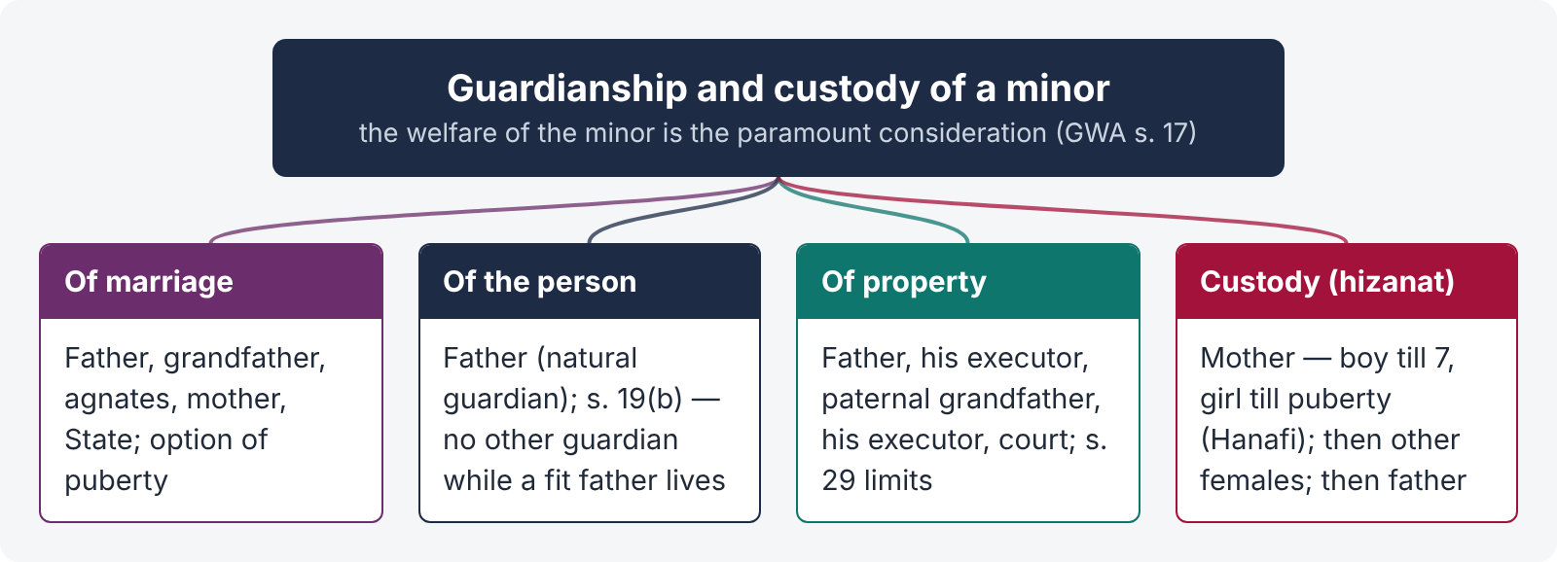
Figure 5 · Guardianship and custody — the structure
- Guardianship in marriage (wilayat-e-nikah) — to contract the marriage of a minor (Chapter 2).
- Guardianship of the person (wilayat-e-nafs) — the right and duty to control and educate the minor; under Muslim law it belongs primarily to the father.
- Guardianship of property (wilayat-e-mal) — the right to manage the minor's property.
Distinct from these is custody (hizanat) — the physical care and upbringing of the young child, which Muslim law gives primarily to the mother and female relations.
Point | Guardianship (wilayat) | Custody (hizanat)
Nature | Legal authority over the minor's person and property | Physical care and upbringing of a young child
Primarily belongs to | The father, then his executor, the paternal grandfather and his executor | The mother, then other female relations (in a fixed order)
Duration | Until majority (18; 21 if a court guardian is appointed — Majority Act s. 3) | Hanafi: boy till 7, girl till puberty (subject to welfare)
Can be lost | By removal under GWA s. 39 | By the hazina's disqualification (9.3)
Effect | Father remains guardian even when mother has custody — decides education, religion, residence (subject to court) | Does not give control of property or the right to change the child's religion

LEGAL MAXIM · The welfare of the minor is the paramount consideration
In every custody and guardianship dispute, the court is guided by what appears to be for the welfare of the minor, consistently with the law to which the minor is subject (GWA s. 17(1)). The rules of hizanat are guides to the minor's welfare, not rigid rights of parents.

9.2 Custody (hizanat) — the right of the mother
Hanafi periods: the mother is entitled to custody of her son until he completes seven years and of her daughter until she attains puberty. (Shia: son till 2 years, daughter till 7; Maliki: son till puberty, daughter till marriage.)
Order of female hazinas (Hanafi) if the mother is absent or disqualified: (1) mother's mother, how high soever; (2) father's mother, how high soever; (3) full sister; (4) uterine sister; (5) consanguine sister; (6) full sister's daughter; (7) uterine sister's daughter; (8) consanguine sister's daughter; (9) maternal aunts; (10) paternal aunts. After the females, custody goes to the father and other male agnates.
After the period of hizanat custody goes to the father (or other guardian), subject to the welfare of the minor.

9.3 Disqualifications of a hazina
The mother (or other female) loses her right of hizanat if she:
- Marries a person not related to the child within the prohibited degrees (a "stranger" to the child) — her right revives on the dissolution of that marriage (Hanafi);
- leads an immoral life (e.g., is a prostitute);
- neglects the child or is cruel to it;
- changes her residence to a distant place so that the father cannot exercise supervision;
- is of unsound mind or suffers from a contagious disease rendering her unfit;
- apostatises (where this affects the child's welfare), or is non-Muslim — in Pakistani practice, only if it endangers the child's upbringing in his faith;
- demands remuneration where another female relation will look after the child for free (classical);
- lives in a house where the child may be ill-treated.
Welfare overrides. Pakistani courts consistently hold that these disqualifications are not absolute: even a mother who has remarried may keep custody if the child's welfare so requires (e.g., the father is unfit, or a change of custody would harm the child); and the father may get custody before the end of hizanat if the mother is unfit.
CASE STUDY · Mst. Zohra Begum v. Sh. Latif Ahmad Munawwar (PLD 1965 Lahore 695, Full Bench)
Held. The rules of Muslim law on hizanat are founded on the welfare of the minor; the court's paramount duty under the Guardians and Wards Act is to see what is for the minor's welfare. The mother's right to custody is not an absolute right that she can claim regardless of the child's welfare, and her remarriage does not automatically defeat her custody where the welfare of the child requires that the child remain with her.
Ratio. Personal-law rules of custody are presumptions of what is good for the child; they yield to the minor's welfare in the facts of each case.

9.4 Guardianship of the property under Muslim law
Legal guardians of property (in order): (1) the father; (2) the executor appointed by the father's will; (3) the paternal grandfather; (4) the executor appointed by the grandfather's will; (5) the court. The mother, brother and uncle are not legal guardians of property, though they may be appointed by the court or act as de facto guardians.
Powers of a legal guardian (classical): to sell or mortgage movables for the minor's necessities; to sell immovables only in specified cases — e.g., double the value is offered, the minor has no other means of support, there are debts of the deceased to be paid, the property is falling into ruin, or the expenses exceed the income.
De facto guardian (a person who, without legal authority, takes charge of the minor's property): has no power to alienate the minor's immovable property; such a transfer is void.
CASE STUDY · Imambandi v. Mutsaddi ((1918) 45 IA 73, Privy Council)
Held. A Muslim mother, who is not a legal guardian of property, has no power, as a de facto guardian, to transfer her minor children's interest in immovable property; such a transfer is void (a nullity), not merely voidable, and cannot be ratified by the minor on attaining majority.

9.5 The Guardians and Wards Act 1890
The Act supplements personal law: the court applies the minor's personal law but always for the minor's welfare. In the ICT, the Family Court is deemed the District Court for the purposes of this Act (s. 25, Family Courts Act).

(1) Appointment or declaration — ss. 7 to 19
- Power — s. 7: where the Court is satisfied that it is for the welfare of a minor, it may make an order appointing a guardian of his person or property or both, or declaring a person to be such a guardian. An order impliedly removes any guardian not appointed by will or court.
- Who may apply — s. 8: (a) the person desiring to be or claiming to be the guardian; (b) any relative or friend of the minor; (c) the Collector of the district where the minor ordinarily resides or has property; (d) the Collector having authority over the minor's class.
- Which court — s. 9: for the person — the District Court where the minor ordinarily resides; for property — that court, or a District Court where he has property (which may return the application to a more convenient court).
- Form — s. 10: a petition, signed and verified like a plaint, stating the minor's name, sex, religion, date of birth, residence, the proposed guardian, the minor's property, etc.
- Interim orders — s. 12: the Court may direct the person having custody to produce the minor and make orders for temporary custody and protection of the person or property of the minor (a female minor to be produced in accordance with custom; no temporary custody to a "husband" of a female minor unless she is already with him with her parents' consent).
- Welfare and factors — s. 17: "In appointing or declaring the guardian of a minor, the Court shall … be guided by what, consistently with the law to which the minor is subject, appears in the circumstances to be for the welfare of the minor" (s. 17(1)). The Court shall have regard to the age, sex and religion of the minor, the character and capacity of the proposed guardian and his nearness of kin, the wishes of a deceased parent, and any existing or previous relations of the proposed guardian with the minor or his property (s. 17(2)). If the minor is old enough to form an intelligent preference, the Court may consider it (s. 17(3)). No one shall be appointed against his will (s. 17(5)).
- Where no guardian of the person may be appointed — s. 19: (a) a married female minor whose husband is not unfit; (b) a minor whose father is living and is not, in the Court's opinion, unfit to be guardian of the person; (c) a minor whose property is under a Court of Wards. (The father may still lose custody where welfare so requires — custody and guardianship being different.)

(2) Duties, rights and liabilities — ss. 20 to 37
- Fiduciary relation — s. 20: the guardian stands in a fiduciary relation to the ward and must make no profit from his office; the relation affects purchases between them immediately or soon after the ward attains majority.
- Minor as guardian — s. 21: a minor is incompetent to act as guardian except of his own wife or child.
- Guardian of the person — s. 24: "charged with the custody of the ward and must look to his support, health and education and such other matters as the law to which the ward is subject requires".
- Return of the ward — s. 25: if a ward leaves or is removed from the custody of a guardian of his person, the Court, if it thinks it is for the welfare of the ward to return, may order his return and enforce it by arrest (using a Magistrate's powers under s. 100 CrPC). The father's or mother's custody suits are commonly brought under s. 25. Residence of the ward elsewhere against the guardian's will does not itself end the guardianship (s. 25(3)).
- Removal from jurisdiction — s. 26: a court-appointed guardian of the person may not remove the ward from the Court's jurisdiction without leave.
- Guardian of property — s. 27: must deal with the property "as carefully as a man of ordinary prudence would deal with it if it were his own", and may do all acts reasonable and proper for its realisation, protection or benefit.
- Testamentary guardian — s. 28: his power to deal with immovable property is subject to restrictions in the will, unless the Court permits.
- Limits on a court-appointed guardian of property — s. 29: he shall not, without the previous permission of the Court, (a) mortgage, charge, sell, gift, exchange or otherwise transfer any part of the ward's immovable property, or (b) lease it for more than five years or for any term extending more than one year beyond the ward's majority.
- Voidable — s. 30: a disposal in contravention of s. 28 or 29 is voidable at the instance of any person affected.
- Permission — s. 31: shall not be granted "except in case of necessity or for an evident advantage to the ward"; the order must recite the necessity or advantage and describe the property, and the Court may require the sale by auction, etc.
- Accounts and liability — ss. 34–37: a court-appointed guardian of property may be required to give a bond, exhibit an inventory and render accounts; he is liable as a trustee (s. 37).

(3) Termination — ss. 38 to 42
Removal — s. 39. The Court may, on the application of any person interested or of its own motion, remove a guardian appointed or declared by the Court, or appointed by will, for:
(a) abuse of trust; (b) continued failure to perform the duties of the trust; (c) incapacity to perform them; (d) ill-treatment or neglect of the ward; (e) contumacious disregard of the Act or the Court's orders; (f) conviction of an offence implying a defect of character unfitting him; (g) an interest adverse to the faithful performance of his duties; (h) ceasing to reside within the Court's jurisdiction; (i) for a guardian of property, bankruptcy or insolvency; (j) his guardianship ceasing, or being liable to cease, under the minor's personal law. A testamentary guardian is not removed under (g) or (h) except in the limited cases in the proviso.
Discharge — s. 40 (on resignation); cessation — s. 41: a guardian of the person ceases by his death, removal or discharge; the Court of Wards assuming superintendence; the ward attaining majority; a female ward's marriage to a husband not unfit; or the father ceasing to be unfit. A guardian of property ceases by his death, removal or discharge; the Court of Wards; or the ward's majority. On cessation the Court may require delivery of property and accounts (s. 41(3)–(4)).
Successor — s. 42; joint guardians — s. 38 (survivorship).

(4) Appeals — s. 47
An appeal lies (to the High Court, or to the District Court where the order is passed by a subordinate officer) against orders appointing or refusing to appoint a guardian (s. 7), returning an application (s. 9(3)), making or refusing an order for return of the ward (s. 25), refusing leave to remove the ward (s. 26), refusing permission under ss. 28–29, removing a guardian (s. 39), refusing discharge (s. 40), and others. Where the Family Court decides a guardianship matter, the appeal provisions of the Family Courts Act (s. 14) govern.

9.6 Visitation (meeting schedule) and modern practice
When custody is given to one parent, the Court fixes a schedule of meetings for the other (weekly visits, school holidays, Eid days, video calls), as the child's welfare requires a relationship with both parents. Courts consider the child's preference (s. 17(3)) where mature, keep siblings together, and avoid frequent changes of custody. Mediation and reconciliation are encouraged at every stage (Family Courts Act ss. 10, 12) — the theme of the ASJ 2025 question.
ILLUSTRATION · A custody dispute in Islamabad
Amna and Bilal divorced; their son Ali is 9 and daughter Hira is 5. Amna has remarried a man who is not related to the children. Bilal applies under s. 25 GWA for custody of both.
- Ali (9) — the mother's hizanat for a boy ended at 7; prima facie the father is entitled, but the Court asks what is best for Ali's welfare (his schooling, attachment, the father's circumstances) and may consider his preference (s. 17(3)).
- Hira (5) — within the mother's period of hizanat, but the mother's marriage to a stranger is a disqualification; the right passes to the maternal grandmother if she is fit and willing. Yet if Hira's welfare requires her to stay with her mother (e.g., the stepfather is kind, the father is unable to care for her), the Court may leave her with the mother (Zohra Begum).
- Whoever gets custody, the Court will fix a visitation schedule for the other parent; the father remains liable for maintenance of both children (Chapter 7) and remains their natural guardian (s. 19(b)).

QUICK RECAP · Chapter 9 in nine lines
- Wilayat (marriage, person, property) vs hizanat (physical custody); welfare paramount (GWA s. 17).
- Hizanat (Hanafi): mother — son till 7, daughter till puberty; then mother's mother, father's mother, sisters, aunts…; then father.
- Disqualifications: marriage to a stranger (revives on dissolution), immorality, neglect, distant residence, unsoundness, etc. — all subject to welfare (Zohra Begum, PLD 1965 Lah 695 FB).
- Guardians of property: father, his executor, paternal grandfather, his executor, court; mother is not; de facto guardian cannot alienate immovables (Imambandi v. Mutsaddi).
- GWA: welfare (s. 7); who applies (s. 8); court of ordinary residence (s. 9); interim custody (s. 12); factors and minor's preference (s. 17); living fit father — no guardian of person (s. 19(b)).
- Duties: fiduciary (s. 20); person — custody, support, health, education (s. 24); return of ward (s. 25); removal from jurisdiction (s. 26); property — ordinary prudence (s. 27).
- s. 29 — no transfer of immovables or lease > 5 years / beyond majority + 1 year without permission; voidable (s. 30); permission only for necessity or evident advantage (s. 31); trustee (s. 37).
- Removal (s. 39 (a)–(j)); discharge (s. 40); cessation (s. 41); appeals (s. 47; FCA s. 14).
- Visitation schedules; mediation; Family Court as District Court (FCA s. 25).

Chapter 10 · The Family Court — jurisdiction and procedure
The West Pakistan Family Courts Act 1964, as amended (notably by the Family Courts (Amendment) Ordinance 2002), applies in the Islamabad Capital Territory. It creates special courts and a simplified, speedy procedure for family disputes. (Section references below are to that Act.)

10.1 Object
To provide for the establishment of Family Courts "for the expeditious settlement and disposal of disputes relating to marriage and family affairs and for matters connected therewith" (Preamble). The Act emphasises reconciliation, speed and simplicity.

10.2 Exclusive jurisdiction — s. 5 and the Schedule
The Family Court has exclusive jurisdiction to entertain, hear and adjudicate the matters in the Schedule:
- dissolution of marriage, including khula;
- dower;
- maintenance;
- restitution of conjugal rights;
- custody of children and the visitation rights of parents;
- guardianship;
- jactitation of marriage (a false claim that one is married to another);
- dowry; and
- personal property and belongings of a wife.
Civil courts' jurisdiction over these matters is ousted. The Family Court is deemed a District Court for the purposes of the Guardians and Wards Act (s. 25).
Territorial jurisdiction: under the Family Courts Rules 1965 (r. 6), a suit for dissolution of marriage, dower or maintenance may be filed where the wife ordinarily resides (a protection for the wife); other suits where the cause of action arose or the defendant resides.

10.3 Procedure — step by step
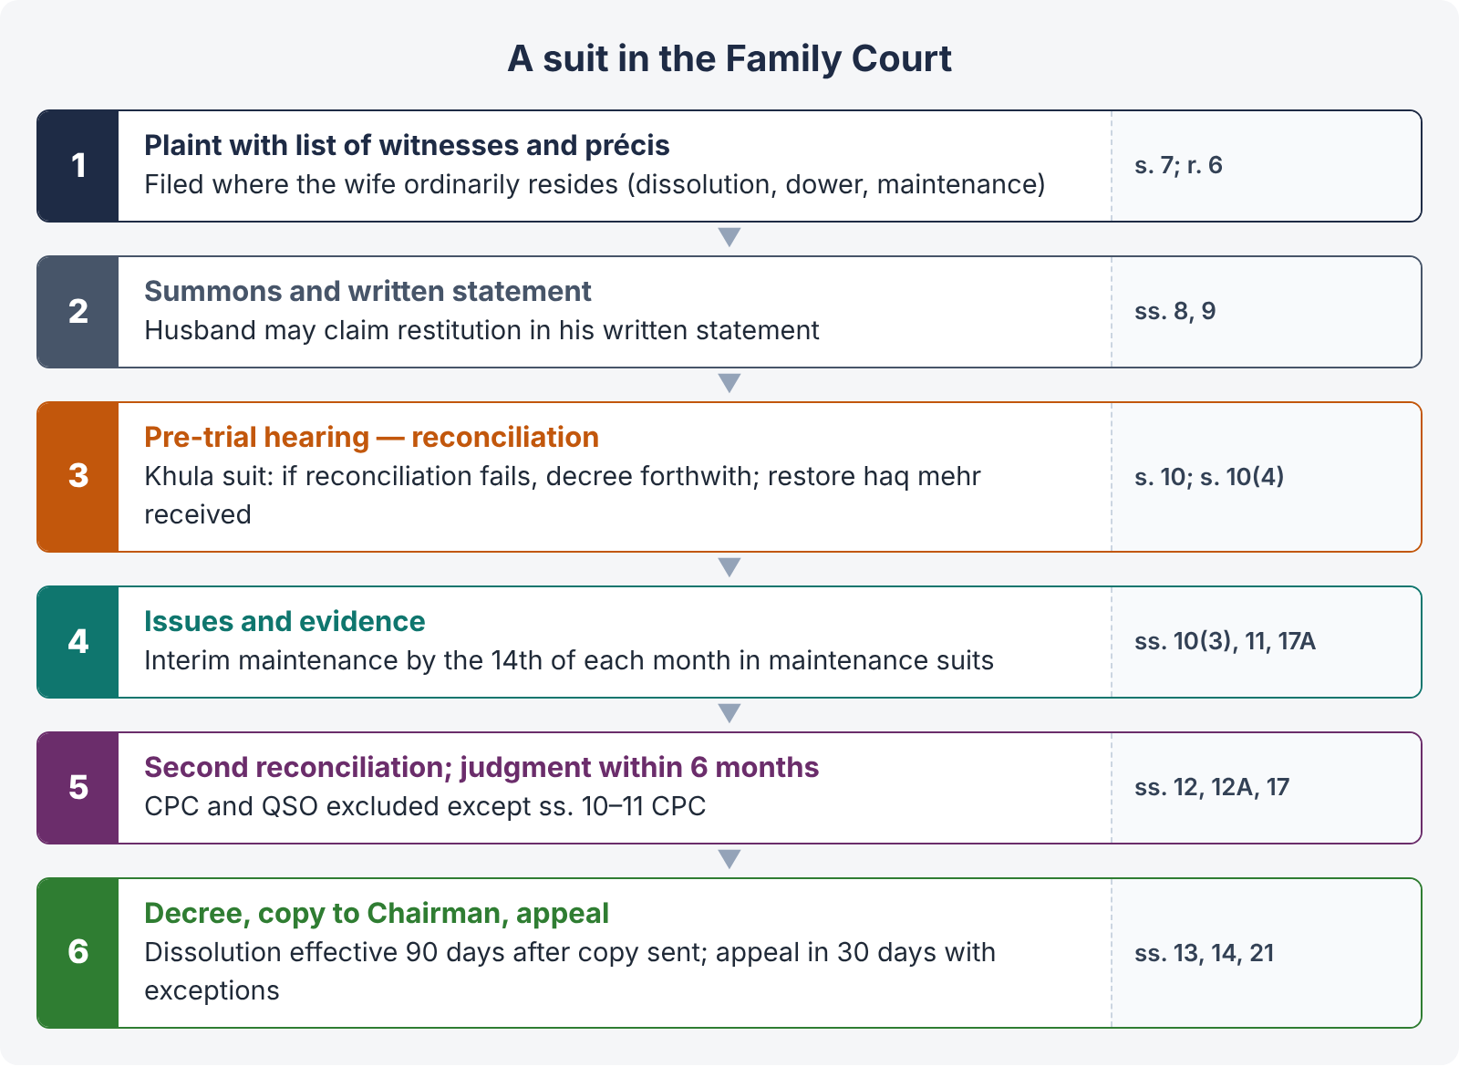
Figure 6 · Procedure in a Family Court suit
- Plaint (s. 7) — with a schedule listing the witnesses and a précis of facts (the substance of each witness's evidence), and the documents relied on. In a suit for dissolution, the plaint also states the dower and dowry, and any claim for their recovery may be joined.
- Summons (s. 8) — served through the process server, by registered post, courier, and other modes including publication; service at the wife's or husband's address as stated.
- Written statement (s. 9) — with a list of witnesses and précis; a husband sued for dissolution or maintenance may claim restitution of conjugal rights in his written statement; the wife may claim dower or dowry in reply to a restitution suit (joinder of claims arising from the marriage).
- Pre-trial hearing (s. 10) — the Court examines the plaint, written statement and précis, ascertains the points at issue and attempts to effect a compromise or reconciliation between the parties, if possible.
- Khula at pre-trial (s. 10(4) proviso) — in a suit for dissolution, if reconciliation fails, the Court "shall pass decree for dissolution of marriage forthwith" and order the wife to restore the haq mehr received at the time of marriage (Chapter 5).
- Issues and evidence (ss. 10(3), 11) — if no compromise, the Court frames issues and records evidence of the witnesses in the schedule (others only with permission); evidence may be recorded in the form of affidavits.
- Second attempt at reconciliation (s. 12) — after the close of evidence, the Court makes another effort at compromise or reconciliation before pronouncing judgment.
- Judgment and decree (ss. 12, 13) — the Court must decide the case within six months of institution (s. 12A); the decree may direct payment in instalments; it is executed by the Family Court as a decree of a civil court.
- Interim maintenance (s. 17A) — at any stage of a suit for maintenance, the Court shall fix interim maintenance payable by the 14th of each month; on default, the defence may be struck off and the suit decreed.
- Decree of dissolution (s. 21) — a certified copy is sent to the Chairman within seven days; the Chairman proceeds as if he had received notice of talaq, and the decree becomes effective 90 days after the copy is sent.

Application of the CPC and the Qanun-e-Shahadat — s. 17
"The provisions of the Qanun-e-Shahadat 1984 and of the Code of Civil Procedure 1908, except sections 10 and 11, shall not apply to proceedings before any Family Court." So the Family Court follows its own simplified procedure; the rules of res sub judice (s. 10 CPC) and res judicata (s. 11 CPC) do apply. In practice, courts apply the principles of the CPC and QSO for justice and fair trial where the Act is silent, without being bound by their technicalities.

Appeal — s. 14
- An appeal lies to the High Court where the Family Court is a District Judge or Additional District Judge, and to the District Judge in other cases, within 30 days (s. 14(1)).
- No appeal lies against a decree (a) for dissolution of marriage, except dissolution under DMMA s. 2(viii)(d) (husband disposing of her property); (b) for dower or dowry not exceeding Rs. 30,000; (c) for maintenance of Rs. 5,000 or less per month (s. 14(2)).
- No appeal or revision lies against an interim order (s. 14(3)).
- Further challenge to the High Court is by way of a constitutional petition (Art. 199) where no appeal lies.

10.4 The significance of pre-trial reconciliation — the LHC 2023 question
- Quranic mandate — "If you fear a breach between them, appoint an arbiter from his family and an arbiter from her family; if they desire reconciliation, Allah will bring about their reconciliation" (4:35).
- Statutory duty — s. 10 (pre-trial) and s. 12 (post-evidence) require the Court to attempt reconciliation; it is not a formality.
- Benefits — saves the marriage where possible; reduces acrimony; protects children's welfare; narrows the issues; resolves ancillary claims (dower, dowry, maintenance, custody) together; reduces the burden of successive suits and counter-claims.
- Danger of a perfunctory effort — a mechanical "reconciliation failed" order encourages hostility, harms the minor, and multiplies litigation (claims and counter-claims for dowry, custody, maintenance). A meaningful attempt involves hearing both parties in chambers, involving family elders or a mediator, exploring practical arrangements, and recording the reasons for failure.
- Khula link — because s. 10(4) requires a decree forthwith on failure of reconciliation, the quality of the reconciliation effort is the wife's main safeguard against hasty dissolution and the husband's main opportunity to save the marriage.
QUICK RECAP · Chapter 10 in six lines
- Family Courts Act 1964 (as amended 2002) applies in the ICT; aim — speedy disposal and reconciliation.
- Exclusive jurisdiction (s. 5, Schedule): dissolution / khula, dower, maintenance, restitution, custody and visitation, guardianship, jactitation, dowry, wife's personal property; deemed District Court for GWA (s. 25); wife's residence (r. 6).
- Procedure: plaint with witnesses' précis (s. 7); summons (s. 8); written statement (s. 9); pre-trial reconciliation (s. 10); khula forthwith on failure, restore haq mehr (s. 10(4)); evidence (s. 11); second reconciliation (s. 12); six months (s. 12A).
- Interim maintenance by the 14th; defence struck off (s. 17A). CPC and QSO excluded except ss. 10–11 CPC (s. 17).
- Dissolution decree: copy to Chairman in 7 days; effective after 90 days (s. 21).
- Appeal (s. 14): HC or DJ, 30 days; none for dissolution (except DMMA 2(viii)(d)), dower / dowry ≤ Rs. 30,000, maintenance ≤ Rs. 5,000 p.m., or interim orders.

Chapter 11 · Maxims and the great distinctions

11.1 Maxims of Muslim family law
Maxim | Meaning | Where it applies
Al-walad lil-firash | The child belongs to the marriage bed | Presumption of legitimacy; Art. 128 QSO
Imsakun bi-ma'rufin aw tasrihun bi-ihsan (Quran 2:229) | Retain her honourably or release her with kindness | Talaq, iddat, khula; maintenance during iddat
La darar wa la dirar | No harm shall be done, nor harm be returned | Judicial dissolution for cruelty; khula; custody
Al-umuru bi-maqasidiha | Matters are judged by their intentions | Implied (kinaya) talaq; acknowledgment of paternity
Abghad al-halal ila Allah al-talaq | The most hateful of lawful things to Allah is divorce | Arbitration Council; reconciliation (FCA ss. 10, 12)
Mahr is a debt | Dower is an obligation enforceable like a debt | Recovery against husband and estate (Hamira Bibi)
Welfare of the minor is paramount | — | Custody and guardianship (GWA s. 17)
Nikah is a contract | Marriage rests on consent and its terms | Conditions in nikahnama; khula; tafweez (Abdul Kadir v. Salima)
Al-ʿadah muhakkamah | Custom is a basis of judgment | Proper dower by family custom; quantum of maintenance

11.2 The great distinctions
Pair | First | Second
Valid vs irregular vs void marriage | Full effects | Irregular — curable defect; effects only after consummation, no inheritance / Void — no effect
Prompt vs deferred dower | Payable on demand; wife may refuse cohabitation before consummation; Art. 103 | Payable on dissolution or agreed event; Art. 104
Specified vs proper dower | Fixed by agreement (minimum 10 dirhams) | By her father's family's dower and personal qualities
Talaq-e-ahsan vs hasan vs biddat | One pronouncement; revocable in iddat | Three in three tuhrs; irrevocable on third / Three at once — irrevocable (Hanafi)
Talaq vs khula | Husband's unilateral act; dower due | Wife's initiative; consideration to husband; court may decree
Khula vs mubarat | Aversion of the wife | Mutual aversion
Khula vs judicial dissolution (DMMA) | No fault needed; dower restored | Proof of a ground; dower preserved (s. 5)
Tafweez vs khula | Wife pronounces under delegated power; dower intact | Wife buys her release; dower returned
Iddat of divorce vs of death | Three courses / three months | Four months ten days; even before consummation
Guardianship vs custody | Legal authority — father | Physical care — mother (boy 7, girl puberty)
Legal vs de facto guardian of property | Father, executor, grandfather, executor, court — may alienate for necessity | No power to alienate immovables (Imambandi)
Court guardian (s. 29) vs testamentary guardian (s. 28) | Court's previous permission needed | Restrictions of the will; Court may permit
Arbitration Council (MFLO) vs Family Court | Administrative body: talaq notice, polygamy permission, maintenance certificate | Court: decrees in all Schedule matters

Chapter 12 · Last-night revision sheet
QUICK RECAP · The 40 points of Topic 1
- Sources: Quran, Sunnah, Ijma, Qiyas; secondary: istihsan, istislah, urf, ijtihad, legislation, precedent.
- Schools: Hanafi (majority), Maliki, Shafi'i, Hanbali; Shia — Jafari (MFLO ss. 4(8), 7(1A) — 2021).
- Shariat Application Act 1962 s. 2 — personal law governs Muslims notwithstanding custom, subject to enactments.
- MFLO s. 3 overrides any law, custom or usage; FSC may examine statutes (Mahmood-ur-Rahman Faisal, PLD 1994 SC 607).
- Allah Rakha (PLD 2000 FSC 1): s. 4 and s. 7(3), (5) repugnant; ss. 5, 6 valid; appeal pending — MFLO applies as enacted.
- Nikah — civil contract with sanctity (Abdul Kadir v. Salima); ijab and qabul at one meeting.
- Essentials: competence, free consent, two witnesses (Hanafi; not Shia), no prohibition; dower an incident.
- Adult woman may marry without wali (Hafiz Abdul Waheed v. Asma Jahangir, PLD 2004 SC 219).
- Guardians for marriage: father, grandfather, agnates, mother, maternal relations, State.
- Option of puberty: DMMA s. 2(vii) — married before 16, repudiate before 18, not consummated.
- Prohibitions: consanguinity, affinity, fosterage — void; conjunction, fifth wife, no witnesses, iddat, religion — irregular.
- Muslim woman may marry only a Muslim; Muslim man may marry a kitabia.
- Halala only after the third effective termination (MFLO s. 7(6)).
- Registration (MFLO s. 5) — non-registration does not invalidate; penalty for not reporting.
- Polygamy (s. 6): previous written permission; "necessary and just"; whole dower at once; one year / Rs. 5,000; DMMA s. 2(iia).
- ICT Child Marriage Restraint Act 2025: 18 for both; Nikah Registrar barred; punishments; Sessions Court; injunction; 90 days.
- Dower is a debt (Hamira Bibi); purposes — respect, check on divorce, security.
- Specified (minimum 10 dirhams; prompt or deferred) and proper dower.
- MFLO s. 10 — mode not specified → whole dower payable on demand.
- Refuse cohabitation before consummation (Nasra Begum); widow's right of retention — no title, no alienation (Maina Bibi).
- Dower confirmed by consummation, valid retirement, death; half on divorce before consummation.
- Limitation: prompt — Art. 103 (demand and refusal / dissolution); deferred — Art. 104 (dissolution); 3 years each.
- Dowry and bridal gifts vest absolutely in the bride (Act of 1976).
- Talaq modes: ahsan, hasan, biddat (Rashid Ahmad v. Anisa Khatun); ila, zihar.
- MFLO s. 7: notice to Chairman, copy to wife; Arbitration Council within 30 days; effective after 90 days unless revoked; pregnancy; penalty.
- Non-notice — predominant view: talaq effective only from notice + 90 days; FSC's contrary view under appeal.
- Fiqh-e-Jafria talaq — Arabic words, two witnesses, ineffective in jest, anger, intoxication, insanity, duress.
- Tafweez — clause 18 nikahnama; s. 8 procedure; dower intact.
- Khula: Quran 2:229, Thabit bin Qays; court may decree without husband's consent (Balqis Fatima; Khurshid Bibi, PLD 1967 SC 97).
- FCA s. 10(4): reconciliation fails → decree forthwith; restore haq mehr received.
- DMMA s. 2 grounds: 4 years missing; 2 years' maintenance; MFLO polygamy; 7 years' prison; 3 years' marital failure; impotence; insanity / leprosy / VD; puberty; lian; cruelty (a)–(f); any other ground.
- DMMA s. 3 (heirs, uncle, brother), proviso (b) six months; s. 4 apostasy; s. 5 dower preserved.
- Iddat: three courses / three months; death — 4 months 10 days; pregnancy — delivery; none if divorce before consummation.
- Maintenance of wife — not disobedient; justified refusals; iddat maintenance (not widow).
- Children's maintenance — father: sons till puberty / earning, daughters till marriage; not waivable.
- FCA s. 17A interim maintenance; MFLO s. 9 Arbitration Council certificate; DMMA s. 2(ii).
- Legitimacy: ≥ 6 months after marriage, ≤ 2 years after dissolution (Art. 128 QSO); acknowledgment conditions (Habibur Rahman); no adoption.
- Hizanat: mother — boy 7, girl puberty; order of hazinas; disqualifications subject to welfare (Zohra Begum, PLD 1965 Lah 695 FB).
- Property guardians: father, executor, grandfather, executor, court; mother de facto — no alienation (Imambandi); GWA ss. 7, 8, 9, 12, 17, 19, 24–27, 29–31, 39, 41, 47.
- Family Court: exclusive Schedule jurisdiction; pre-trial and post-evidence reconciliation; six months; CPC / QSO excluded (except ss. 10–11 CPC); s. 21 copy to Chairman; appeals s. 14.

